Name:
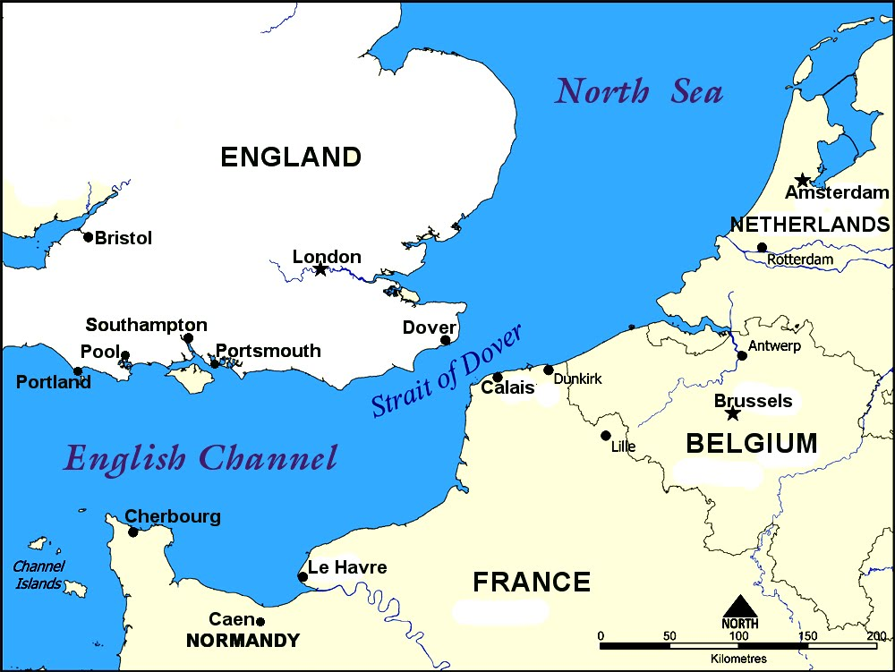
Objective 1: Locate suitable beaches for a significant landing force

Options:
- Pas de Calais: locate Calais on the map.
Calais is a town and ferry port in Northern France. It overlooks the Straight of Dover, the narrowest point in the English Channel. Calais is the command post for the German army in the region and it is heavily fortified. German forces are concentrated in the region and the area is a launching site for V1 flying bombs directed at England. The Germans believe that if and when the Allies invade Europe, they will do so at Calais.
An invasion of Pas de Calais offers the closest and most direct route to Germany. Calais is only 17 miles from the British city of Dover. The beach contains sand worthy of an amphibious assault landing. Moreover, by invading the area, Allied forces can neutralize the V1 bombs.
- Beaches of Normandy:
The beaches of Normandy are also defended by the Atlantic Wall. In recent months, at the direction of German Field Marshall Erwin Rommel, the wall has been strengthened off of the coast of Normandy. Compared to Calais, the beaches of Normandy are less fortified and defended than Calais. Four German divisions are proximate to the area.
The French rail system can easily be cut off in the area, restricting German reinforcements. The beach contains sand worthy of an amphibious assault landing.
- Based on these assessments, why did the Allies choose to invade Normandy instead of Calais?

German Defenses:
German Defenses on the Atlantic Coast were commanded by Field Marshal Erwin Rommel. Rommel had ½ million men manning defenses along a length of the Atlantic coastline stretching eight hundred miles from Holland to the Brittany Peninsula. The fortifications lining the coast line were known by the Germans as the “Atlantic Wall.”
Description of the Atlantic Wall:
“Mines and obstacles were set up to impede or destroy the Allied landing craft before they could unload. They poured concrete for pillboxes and other fortifications which could hold tank turrets, machine guns, anti-tank guns, light artillery, flamethrowers, mortars, rocket-launchers, and radios.
The concrete fortifications were built underground, with some also being built above ground or partially underground. Pillboxes contained embrasures (loopholes) through which to fire the weapons. Various sizes of reinforced concrete Tobruk pits were built entirely underground to support machine guns, mortars, or tank turrets mounted on top. The beach exits (ravines leading from the beach up to the top of the highlands) were most heavily fortified.”
- Who commanded the German Defenses on the Atlantic Coast?

- The German defenses on the Atlantic Coast were known as the __________________________?

- This defense barrier consisted of (list 3) ________________ _________________ __________________
Operation Fortitude:
From 1943, a skilled team of Allied forces worked to create the illusion of a large invasion force being massed in Kent. The illusion was crafted to deceive the German forces into believing the Allied invasion would occur at the Pas-de-Calais. Dummy tanks and aircraft were built of inflatable rubber and placed in realistic looking "camps". Harbors were filled with fleets of mock landing craft. To German reconnaissance aircraft, it all looked real, even down to attempts at camouflage. Knowing that German intelligence would be trying to find out more, double agents planted stories and documents with known German spies. US General Patton was supposedly commander of the non-existent force. Pretend radio transmissions were broadcast, just as if a large army were busy being organized.
The hoax was successful beyond the Allies wildest hopes. German forces were concentrated in the Pas-de-Calais. The deception continued during and after D-Day. While the real invasion force landed in Normandy, Allied planes dropped silver foil to give the impression of massed planes and ships crossing from Dover. The Germans thought the Normandy landings were a diversion, and kept back reserves of tanks and troops in the Calais area - to counter what they thought would be the "real" invasion. By the time they realized, it was too late. The Normandy bridgehead had been secured, and Allied troops were fighting their way across northern France.
- What was the goal of Operation Fortitude?

- Was the operation successful? Why?

