Objective 2: Use paratroopers to isolate the battlefield (beach areas).
- Paratrooper Plan:
The first stage of the attack was carried out by thousands of American, British, and Canadian paratroopers. The paratroopers were dropped under night fall in the early morning hours of June 6th. These men were tasked with blocking strategic highways, bridges, and pathways to delay German reinforcements from arriving at the beach and Normandy.

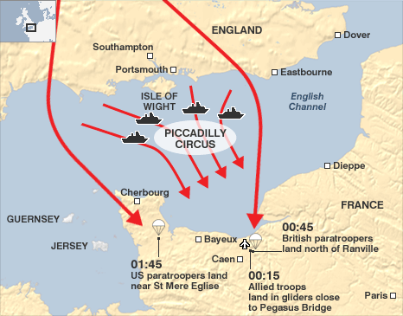

Objective 2: Use paratroopers to isolate the battlefield (beach areas).
- The British 6TH Army Airborne division was assigned the main task of securing and protecting the eastern flank of the invasion site (beaches). To accomplish this task they were directed to ….
•Destroy the bridges over the River Dives..
• Destroy the German Coastal Battery at Merville. This was needed to prevent the battery from shelling the beach during the landing of the Allied seaborne assault force.
• Seize and hold the two bridges over the River Orne and Caen Canal near Bénouville.

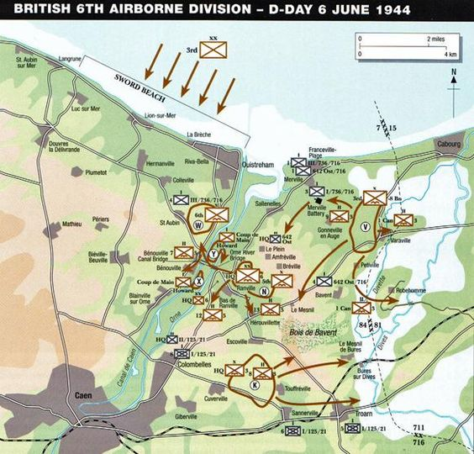

Objective 2: Use paratroopers to isolate the battlefield (beach areas).
- The American 101st and 82nd Airborne divisions were assigned the main task of securing and protecting the western flank of the invasion site. To accomplish this task they were directed to…
- Secure the key communication center of Ste.-Merce-Eglise
- Secure the Cherbough highway
- Dig in at western crossings in preparation to protect the (WEST)rear of the Utah invasion beach.

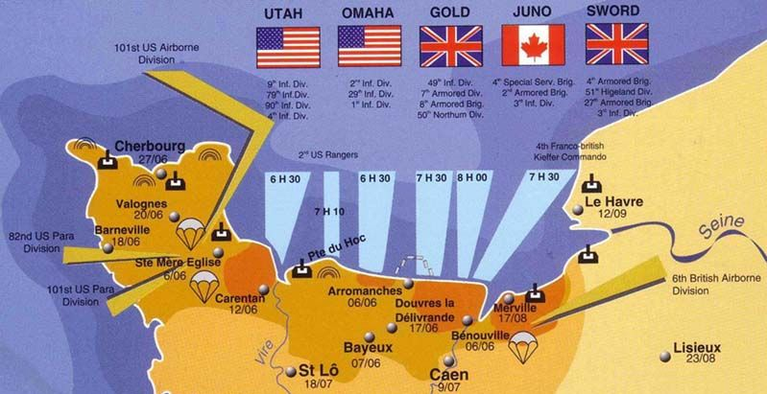

Objective 2: Use paratroopers to isolate the battlefield (beach areas).
- Paratrooper Invasion Account:
Joe Bressler of the 508 recalls the night landing in Normandy
“Once I left the door of the plane, I don’t remember an opening shock. I do remember that I was coming down very fast and was being shot at from a German on the ground.I landed on the other side of a hedgerow. This saved my life since I had the earth wall and shrubbery of the hedgerow as a shield. He was firing over the brush in the center of the hedgerow – slightly over my head. I got closer, I could see the guy shooting. My rifle was in two pieces. I pulled a grenade off my harness and threw the damn grenade. After I threw it I wondered what was next. Is this thing going to come back on my side? Is it going to get caught on top of the hedgerow and were there other troopers close by. That was the longest wait in my life, waiting for that grenade to go off. It took forever to go off so I kept saying to myself why doesn’t it go off? Finally it went off and I didn’t get any more interference from him.
With that behind me, I started moving away from the hedgerow. As I stepped forward could hear a squish sound coming from my boot and felt warm blood. I had a really hard time walking. So I figured the German had hit me. Along came another trooper. I told him I couldn’t walk and he told me to stay put and he would try to round up a few men. I waited about a half an hour and heard the "click - clock" – the distinctive noise of a toy cricket, our signaling device. At this point I met my close friend Prasse and he said come on, lean on your rifle and try to walk forward. I limped along and made it into a large group of paratroopers where a medic examined my foot and determined that I had a compound fracture.”

Objective 2: Use paratroopers to isolate the battlefield (beach areas).
- The end result of the airborne assault:
“It was nearly dawn-the dawn that eighteen thousand paratroopers had been fighting toward. In less than five hours they had more than fulfilled the expectations of General Eisenhower and his commanders. The airborne armies had confused the enemy and disrupted his communications, and now, holding the flanks at either end of the Normandy invasion area, they had to a great extent blocked the movement of enemy reinforcements.
…The men of the Allied airborne armies had invaded the Continent from the air and secured the initial foothold for the invasion from the sea. Now they awaited the arrival of the seaborne forces with whom they would drive into Hitler’s Europe. “(The Longest Day, 169)

