Immigration Issues: Immigration vs. Nativism
The Fear:
- October 1917- Communist Bolsheviks take power in Russia under their leader Vladimir Lenin
- March 1919- Lenin and the Communist Bolsheviks establish the Comintern (Communist International) and vow to lead a worldwide anti-capitalist revolution. The mandate of the comintern was to coordinate Communist activity across the world.
- On May 1st, 1919 postal officials discovered 20 bombs in the mail of prominent capitalists, including John D. Rockefeller and J.P. Morgan, as well as government officials like Supreme Court Justice Oliver Wendell Holmes.
- A mere month later, bombs exploded in eight American Cities.
- The summer of 1919 saw a massive wave of labor strikes in America in what was called the “Red Summer”. The American public associates the strikes with the “Reds”. The term “Red” is used to describe Bolsheviks, communists, socialists, and anarchists. All of these groups are deemed to be anti-American and dangerous.
- On September 16th 1920 a bomb left in a packed horse drawn wagon exploded near Wall Street in Manhattan’s financial district, killing 30 people and injuring hundreds.
- The mail bomb attacks were master-minded by Italian anarchist Luigi Galleani. Luigi Galleani and his followers had published a leaflet stating:
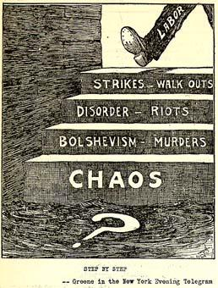
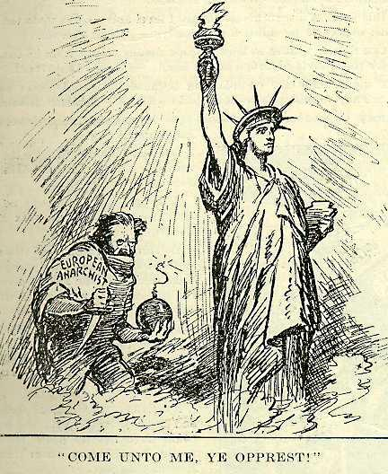
"Deportation will not stop the storm from reaching these shores. The storm is within and very soon will leap and crash and annihilate you in blood and fire…We will dynamite you!".

Reaction:
Immigration Act of 1924:
The quota (number limit) for immigrants entering the U.S. was set at two percent of the total of any given nation`s residents in the U.S. as reported in the 1890 census; after July 1, 1927, the two percent rule was to be replaced by an overall cap of 150,000 immigrants annually.
The clear aim of this law was to restrict the entry of immigrants from Southern and Eastern Europe, while welcoming relatively large numbers of newcomers from Britain, Ireland, and Northern Europe.
Palmer Raids:
In June 1919 eight bombs in eight American cities exploded in minutes of each other. One of the bombs damaged the home of U.S. Attorney General A. Mitchell Palmer. A. Mitchell Palmer subsequently led a campaign against suspected anarchists, communists and other political radicals called the Palmer Raids and fueled fears about the Red Scare. Federal Agents conducted raids on the headquarters of various radical organizations and the homes of immigrants and foreign residents from 1919 - 1920. More than 10,000 suspects were detained without a hearing and nearly 600 immigrants were deported. The agents frequently disregarded the civil liberties of the suspects, entering homes and offices without search warrants. People were often ill-treated and jailed for indefinite periods of time and were not allowed to talk to their lawyers. Abuses of due process, illegal search and seizure, indiscriminate arrests, the use of agents provocateurs and instances of torture were all reported.
Palmer spread various rumors to the press about the dangers of the Red Scare. He announced that undercover federal agents had discovered vast conspiracies aimed at overthrowing the United States government. Headlines of the era screamed: ''Huge Red Plot of Destruction is Uncovered'' or '''No Mercy for Reds behind Gigantic Bomb Plot to Maim and Kill''. Palmer's dire prediction that violence would rock the nation on May Day 1920 had come to nothing. There had been no arrests. The reports of massive bomb plots and acts of terrorism have not materialized. The US government had not been brought down. Post had called the entire effort "a stupendous and cruel fake". The absence of a large scale bombing effectively ended the first Red Scare, but did not stop the surge of Nativism in the United States.

