INDUSTRIAL REVOLUTION
- First Industrial Revolution:
  - Methods:
  - Materials:
  - Power:
    - Robert Fulton invents the ____________ _________

      - What is the benefit of producing a product in a factory?

      - What are some differences between the 1800s factory and the modern day factory?

  - Transcontinental Railroad
    - ______________ Pacific and _____________Pacific
    - Connect America: _________, ___________, and _____

      - In what parts of the country were the first railroads built?

      - In what direction did railroads help people move?

Free Write:
- Second Industrial Revolution (1870-1917)
  - Fueled by 4 major industries:
    - R-
    - O-
    - S-
    - E-
- Resources and Industry in the United States. Label the following industries on the map: oil, coal, iron/steel, textile, meat packing, silver mining, gold mining, and silver mining.
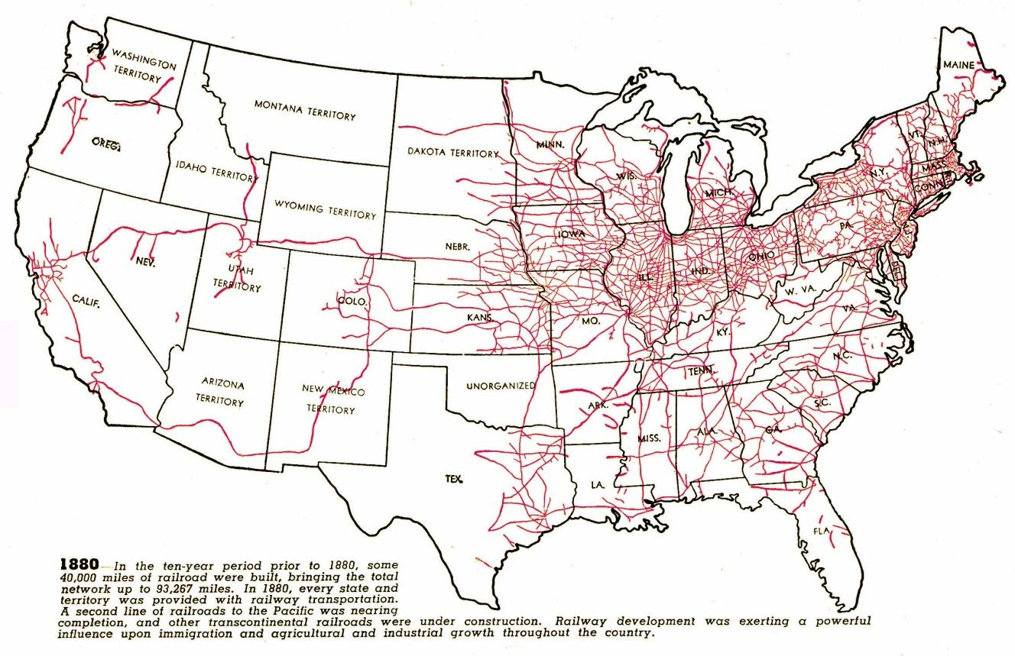

- Second Industrial Revolution (1870-1917)- Bigger, stronger, faster
  - Methods:

  - Materials:

  - Power:

