LIVING AND WORKING CONDITIONS IN GILDED AGE
- URBANIZATION: from the __________________ to the _______________________
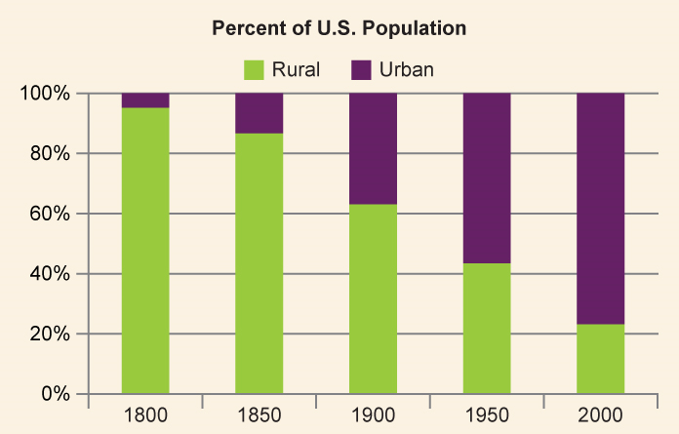
- Describe the trend in the graph above:

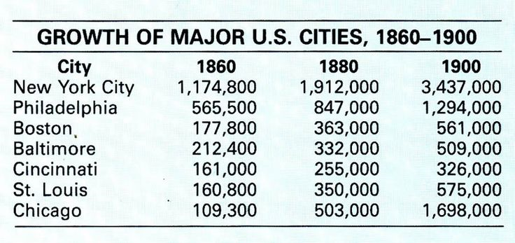
- What occurred in American cities from 1860-1900?

- From what we have learned in this unit, why did this occur?

- Tenement Housing:
- From the pictures and the quotes, what were the living conditions and problems in tenement housing?

- Working Conditions: “Wage Slaves”

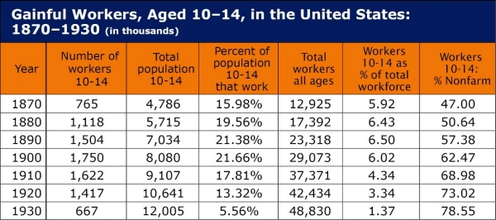

- What does this chart reveal about the workforce during the Gilded Age?

- Describe the two boys in the pictures.

- Describe working conditions in the factories.

- Describe working conditions in the oil/coal industry.

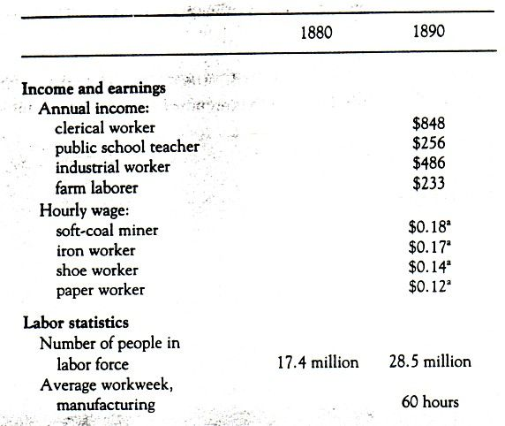
- What problems for workers are revealed in this data? (list at least 2)

