MORAL BATTLE/ GENERATION GAP: MODERN VS. CONSERVATIVE
New Morality:
To counteract the wave of conservatism that was embraced by the masses in post WWI America, a new morality emerged in American cities. For starters, the new morality of the 1920s is often summed up by the word liberalism. The new morality glorified youth and personal freedom and influenced various aspects of American society. Women began to work and go to college. Women's fashion changed as they began to admire the youthful look of movie stars. When we're speaking of this new liberalism, we need to keep in mind that we're usually talking about life in the more metropolitan (urban) areas of the Northern and Western U.S. We're also discussing people of the middle or upper classes.
Jazz Music and the Jazz Age:
Jazz music originated in New Orleans in the early 1900s. European and African music culture combined together with Blues, Ragtime and Dixie and jazz was born. Louis Armstrong is credited with putting Jazz on the musical map. Jazz music, characterized by improvisation and a strong rhythm, was introduced to America during the Harlem Renaissance. Jazz music typified the new morality of youth that dominated the shocking new fashions and lifestyles that emerged during the 1920's "Jazz Age”. The music of the Jazz Age was introduced to Americans due to the introduction of large-scale radio broadcasts in 1922. Americans could listen to the new style of music without leaving their homes of going to a jazz club in a big city. African American Jazz musicians such as like Armstrong initially received very little airtime because most radio stations preferred to play the music of white American jazz singers. Big-band jazz music, like that of Fletcher Henderson and James Reese Europe, attracted large radio audiences.
The Flapper:
The Roaring 20s and the new morality are often associated with the Flapper. The Flappers were the unconventional women who challenged conservative Victorian ideals of womanhood and embraced the new ideas, freedom and modernism of the Roaring Twenties. For many it was a time of prosperity and Flappers enjoyed the new fashions and clothing of the era. They wore make-up, enjoyed Jazz music and danced the crazy, flamboyant dance moves of the Charleston and the Black Bottom which involved flapping their arms around - hence the name "Flappers". “They were smart and sophisticated, with an air of independence about them, and so casual about their looks and clothes and manners as to be almost slapdash. I don't know if I realized as soon as I began seeing them that they represented the wave of the future, but I do know I was drawn to them. I shared their restlessness, understood their determination to free themselves of the Victorian shackles of the pre-World War I era and find out for themselves what life was all about.” ― Colleen Moore
Flapper Fashion:
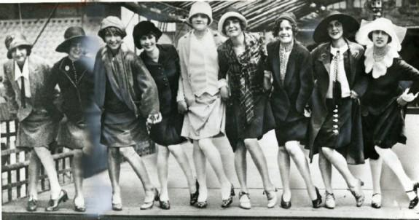

Opposition to the New Morality:
The most fervent opposition to the New Morality came from conservative white Protestants who inhabited rural and suburban areas. Traditionalists feared that the ' New Morality' of the Roaring Twenties period was taking over the nation by threatening family values and the traditional role of women in the home. The personal freedom and new ideas craved by the youth culture added to the fears.
Both conservative men and women opposed the Flapper style and way of life. For these people, the traditional role of a woman was still essential in American society. The woman was the primary caregiver for children and should serve her family and her husband.
“Now I am old-fashioned. A woman, I consider, should be womanly. I have no patience with the modern neurotic girl who jazzes from morning to night, smokes like a chimney, and uses language which would make a billingsgate fish woman blush!” ― Agatha Christie, author
Describing flappers “…morbid women who smoke, wear short skirts, perform obscene dances, favor one piece bathing suits, listen to jazz, practice birth control and lean towards Bolsheviks’.” ---Ladies Home Journal
Opposition to Jazz:
Not everyone approved or appreciated jazz music. Anne Faulkner, head of the music division of the General Federation of Women's Clubs described jazz as "a destructive dissonance". Other conservative Americans called jazz the “devil’s music.” As jazz's popularity grew, so did campaigns to censor "the devil's music." Early detractors like Thomas Edison, inventor of the phonograph, ridiculed jazz, saying it sounded better played backwards. Adults were especially concerned with the music craze. They were worried that their children would be morally corrupted by a style of music without strict order that promoted lively dancing. Moreover, interracial encounters troubled many conservative white citizens. By the end of the 1920s, at least sixty communities across the nation had enacted laws prohibiting jazz in public dance halls.
