Author: Ida Tarbell
Book: History of the Standard Oil Company
Mr. Rockefeller . . . secured an alliance with the railroads to drive out rivals. For fifteen years he received rebates (kickbacks) of varying amounts on at least the greater part of his shipments, and for at least a portion of that time he collected drawbacks of the oil other people shipped; at the same time he worked with the railroads to prevent other people getting oil to manufacture, or if they got it he worked with the railroads to prevent the shipment of the product. If it reached a dealer, he did his utmost to bully or scare him to stop his order. There is no independent refiner or jobber who tries to ship oil freight that does not meet constant discouragement and discrimination. They are all afraid of offending the Standard Oil Company.” . . .
[A] community of deals and arrangements exist between railroads and the Standard Oil Company strong enough for Standard oil to get any help it wants in making it hard for rivals to do business. The Standard owns stock in most of the great systems. It is represented on the board of directors of nearly all the great systems, and it has an immense freight not only in oil products, but in timber, iron, acids, and all of the necessities of its factories. It is allied with many other industries, iron, steel, and copper, and can swing freight away from a road which does not oblige it. It has great influence in the stock market and can depress or inflate a stock if it sets about it. Little wonder that the railroads, being what they are, are afraid to “disturb their relations with the Standard Oil Company
So long as the Standard Oil Company can control transportation as it does to-day, it will remain master of the oil industry, and the people of the United States will pay for their indifference and stupidity. . . . . . . We are a commercial people. We cannot brag of our arts, our crafts, our cultivation; our boast is in the wealth we produce. As a consequence business success is sanctified, and, practically, any methods which achieve it are justified by a larger and larger class. . .

Author: Lincoln Steffens:
Book: The Shame of the Cities
Because politics is business. That's what's the matter with it.
Many politicians have gone out into business and done well (Tammany ex-mayors, and nearly all the old bosses of Philadelphia are prominent financiers in their cities), and business men have gone into politics and done well (Mark Hanna, for example). They haven't reformed their adopted trades, however, though they have sometimes sharpened them most pointedly. The politician is a business man with a specialty. When a business man of some other line learns the business of politics, he is a politician, and there is not much reform left in him. Consider the United States Senate, and believe me.
The commercial spirit is the spirit of profit, not patriotism; of credit, not honor; of individual gain, not national prosperity; of trade and dickering, not principle. "My business is sacred," says the business man in his heart. "Whatever prospers my business is good; it must be. Whatever hurts it, is wrong; it must be. A bribe is bad, that is, it is a bad thing to take; but it is not so bad to give one, not if it is necessary to my business." "Business is business" is not a political idea, but our politician now believes it. He takes essentially the same view of the bribe, only he saves his self-respect by piling all his contempt upon the bribe-giver, and he has the great advantage of candor. "It is wrong, maybe," he says, "but if a rich merchant can afford to do business with me for the sake of a convenience or to increase his already great wealth, I can afford, for the sake of a living, to meet him half way. I make no pretensions to virtue, not even on Sunday." And as for giving bad government or good, how about the merchant who gives bad goods or good goods, according to the demand?
But do the people want good government? Tammany says they don't. Are the people honest? Are the people better than Tammany? Are they better than the merchant and the politician? Isn't our corrupt government, after all, representative of the people it serves?

Author: Upton Sinclair
Book: The Jungle
“Of the butchers and floorsmen, the beef-boners and trimmers, and all those who used knives, you could scarcely find a person who had the use of his thumb; time and time again the base of it had been slashed, till it was a mere lump of flesh against which the man pressed the knife to hold it. The hands of these men would be criss-crossed with cuts, until you could no longer pretend to count them or to trace them. They would have no nails,—they had worn them off pulling hides; their knuckles were swollen so that their fingers spread out like a fan. There were men who worked in the cooking-rooms, in the midst of steam and sickening odors, by artificial light; in these rooms the germs of tuberculosis might live for two years, but the supply was renewed every hour. There were the beef-luggers, who carried two-hundred-pound quarters into the refrigerator-cars; a fearful kind of work, that began at four o’clock in the morning, and that wore out the most powerful men in a few years. There were those who worked in the chilling-rooms, and whose special disease was rheumatism; the time-limit that a man could work in the chilling-rooms was said to be five years. There were the woolpluckers, whose hands went to pieces even sooner than the hands of the pickle-men; for the pelts of the sheep had to be painted with acid to loosen the wool, and then the pluckers had to pull out this wool with their bare hands, till the acid had eaten their fingers off.”

“…It seemed that they must have agencies all over the country, to hunt out old and crippled and diseased cattle to be canned. There were cattle which had been fed on “whiskey-malt,” the refuse of the breweries, and had become what the men called “steerly”—which means covered with boils. It was a nasty job killing these, for when you plunged your knife into them they would burst and splash foul-smelling stuff into your face; and when a man’s sleeves were smeared with blood, and his hands steeped in it, how was he ever to wipe his face, or to clear his eyes so that he could see? It was stuff such as this that made the “embalmed beef” that had killed several times as many United States soldiers as all the bullets of the Spaniards;”

Artist: Thomas Nast
Cartoons printed in the New York Times:
Cartoon #1
Caption reads:
“What are you laughing at? To the victor belong the spoils.”

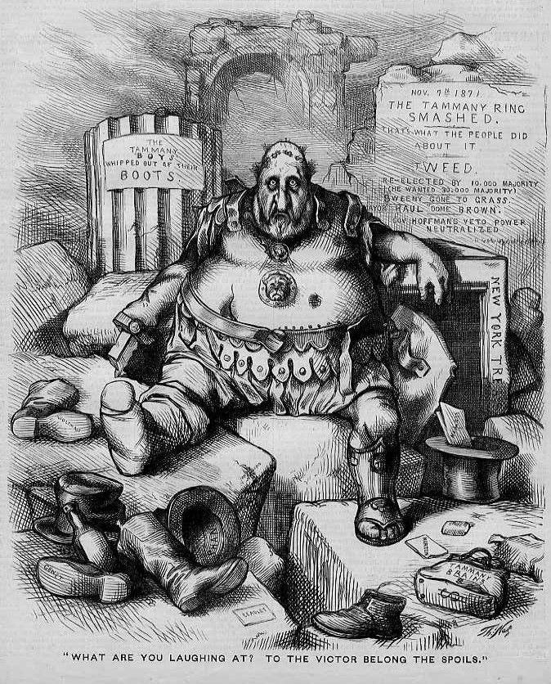
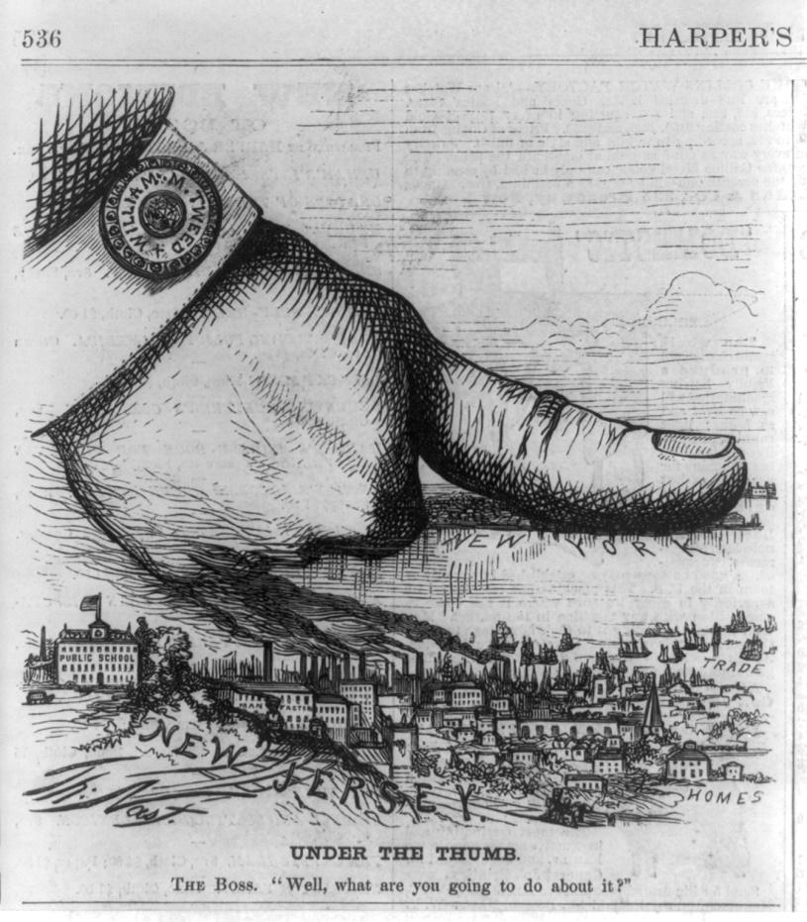
Cartoon #2
Caption reads:
Under the thumb
Boss Tweed: “Well, what are you going to do about it?”

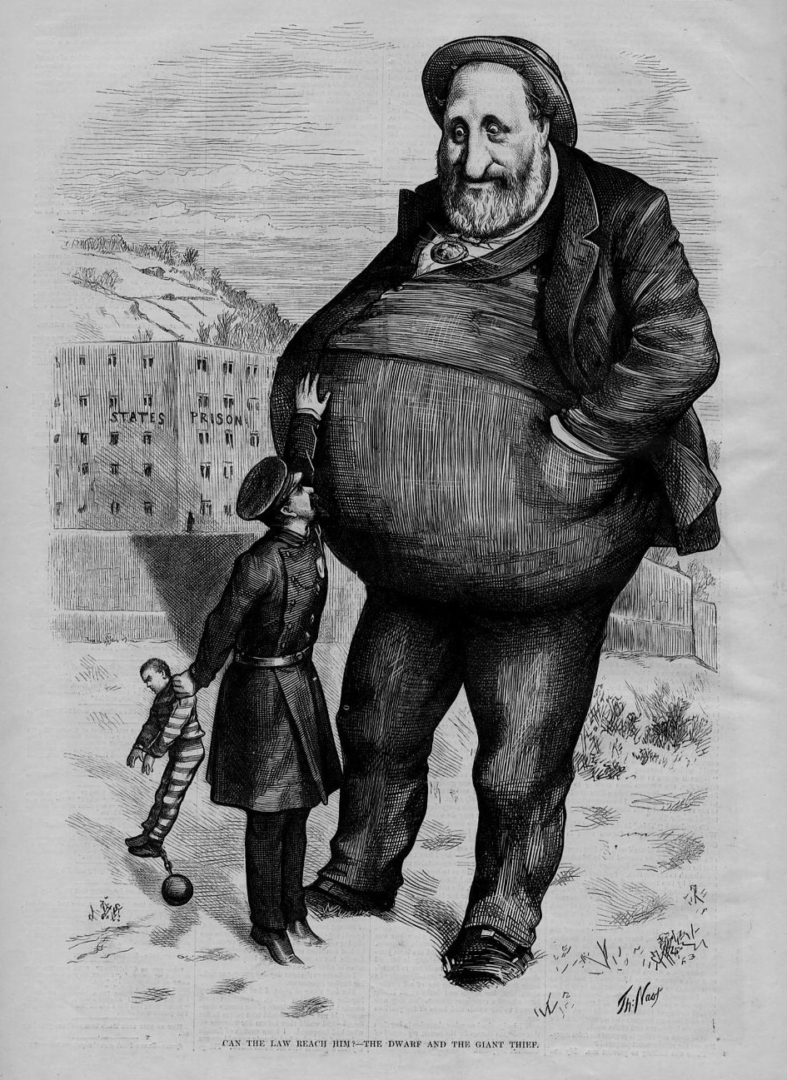
Cartoon #3
Caption reads: “Can the law reach him”?

Photographer: Jacob Riis
Photos published in HOW THE OTHER HALF LIVES

Photo #1: Street Arabs in sleeping quarters [areaway, Mulberry St]

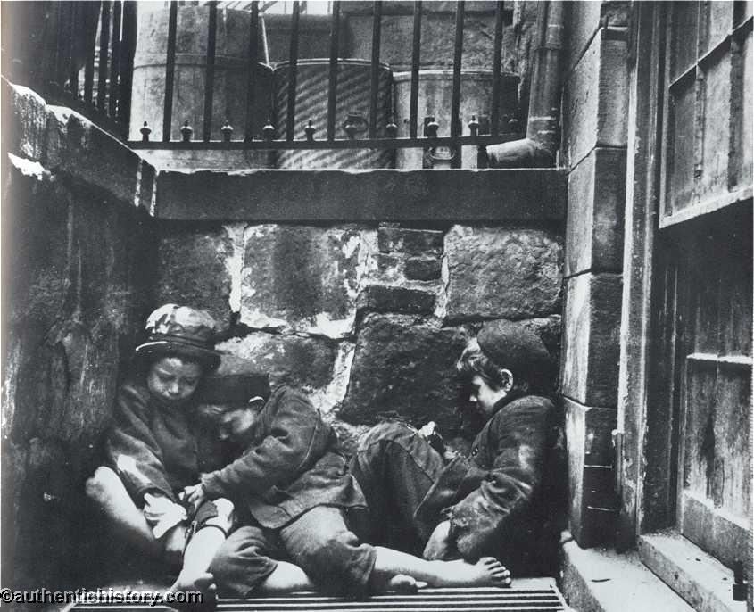

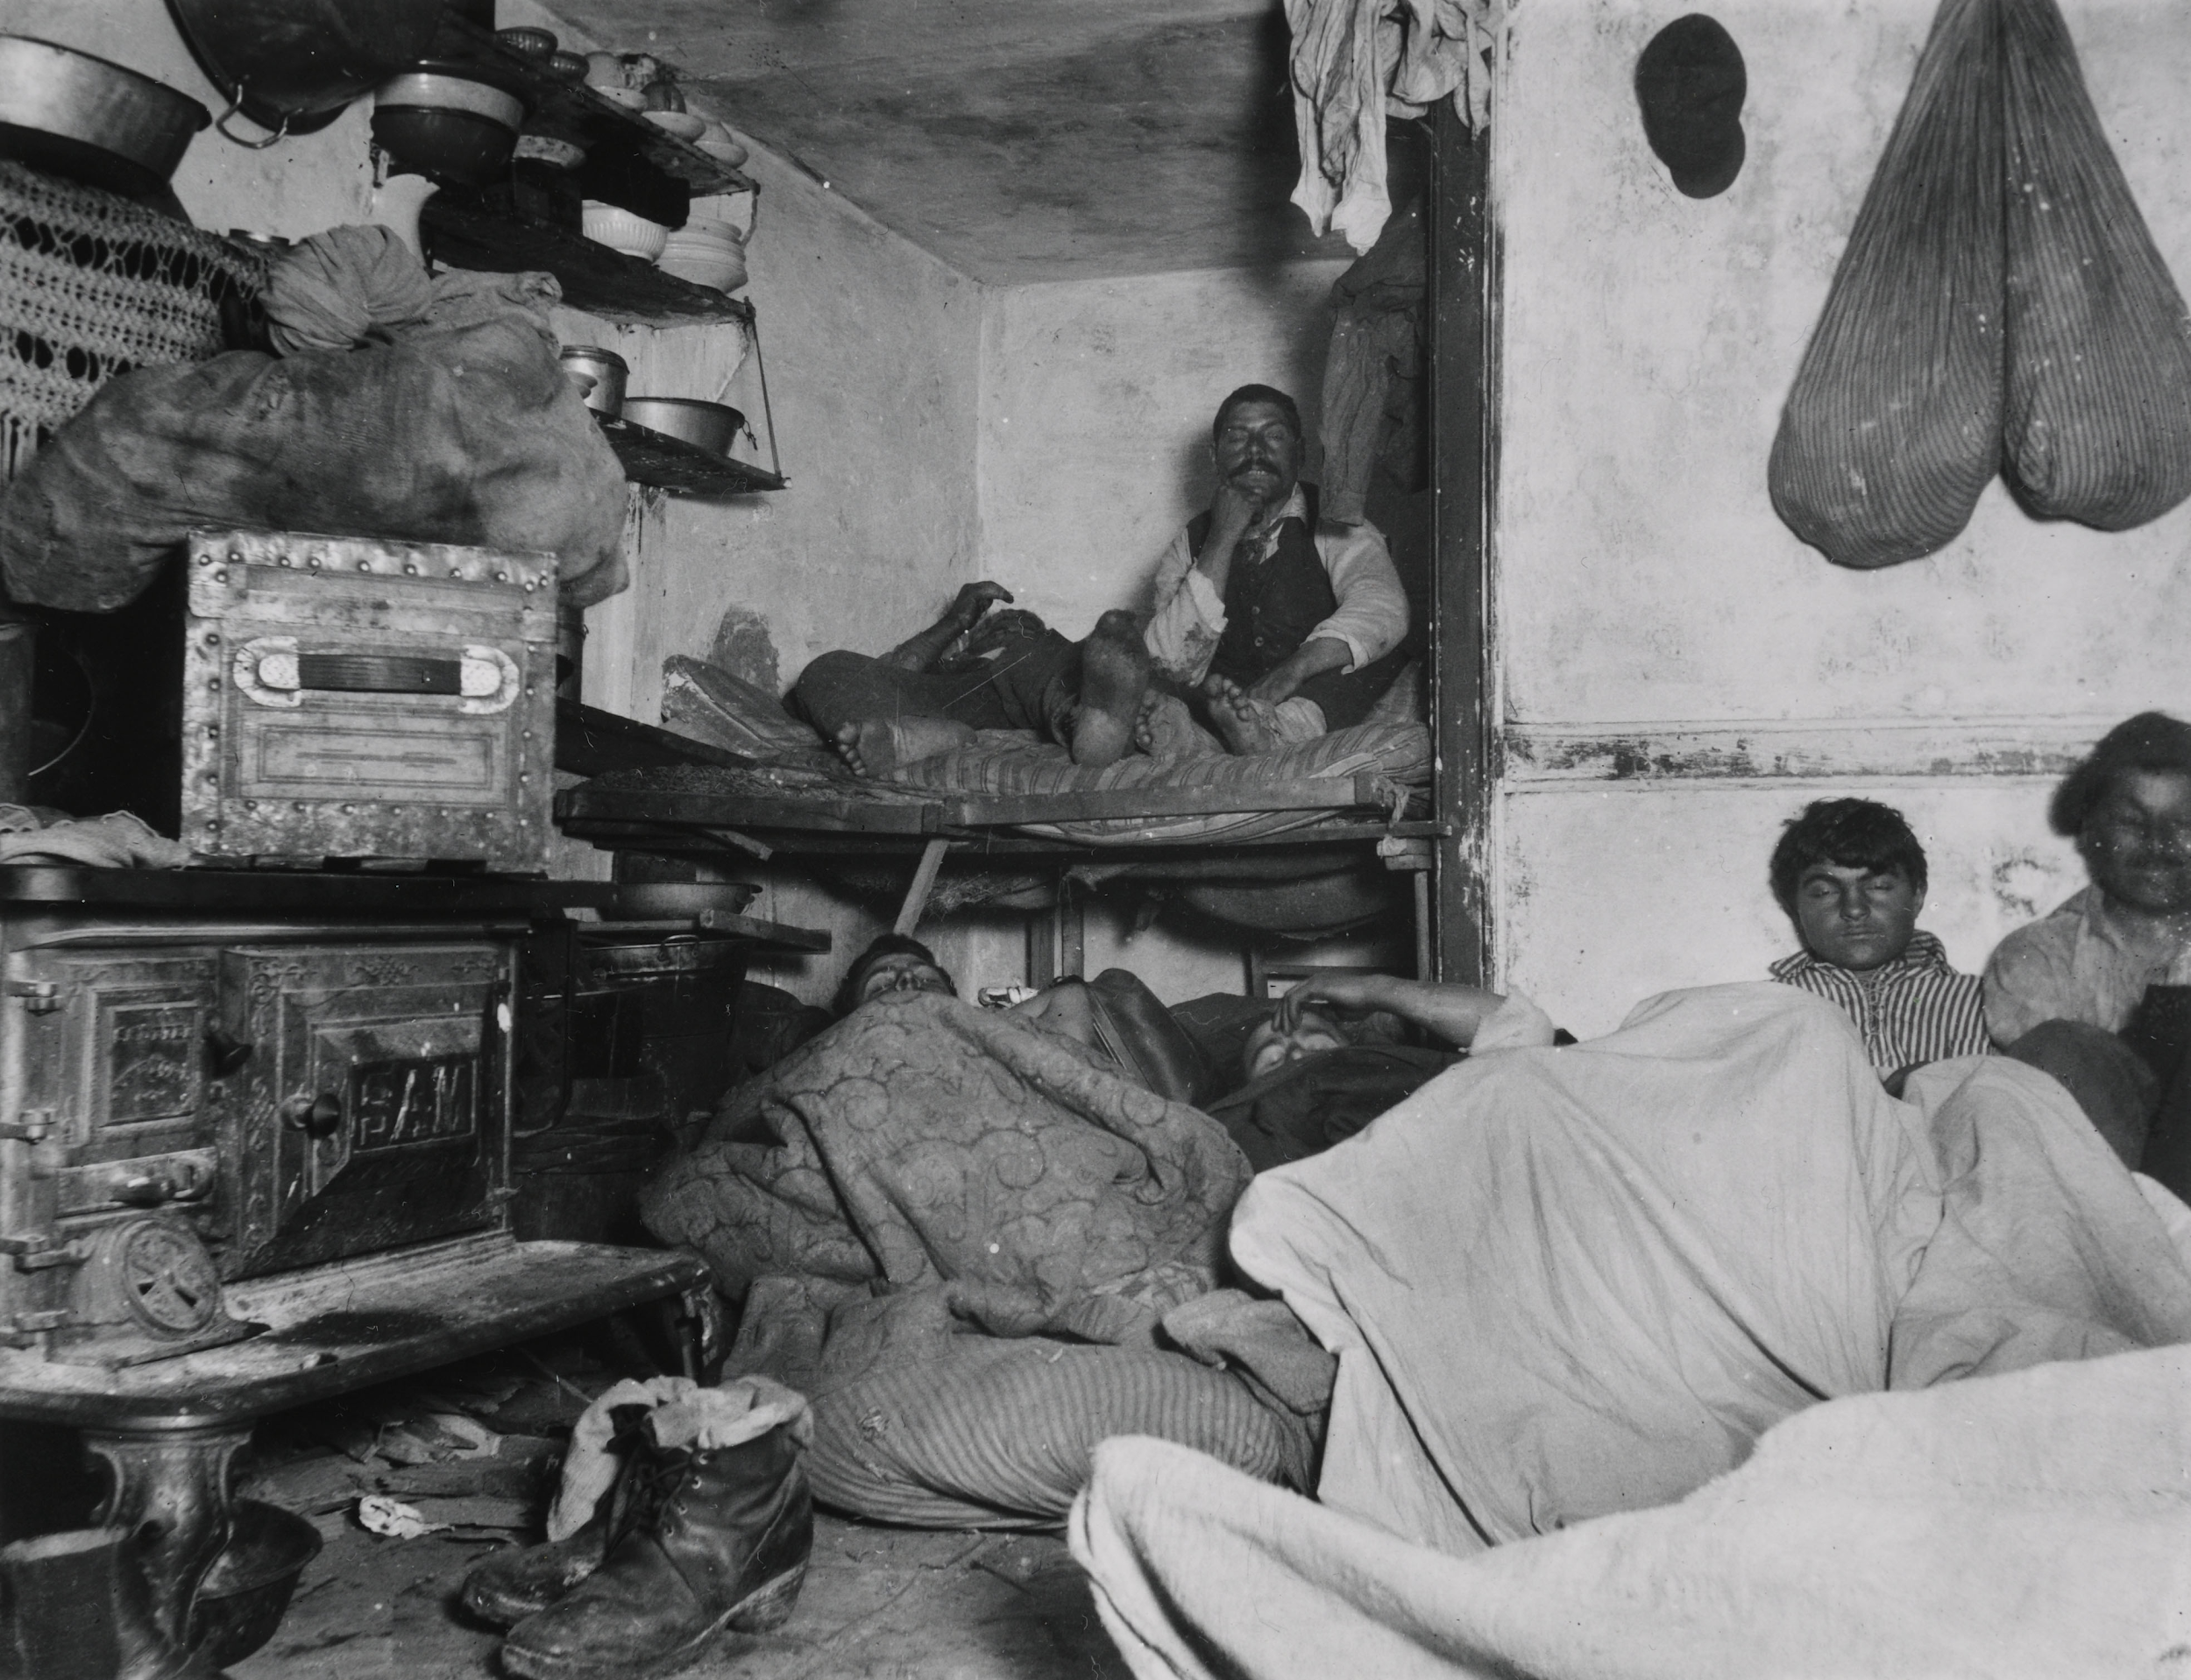

Photo #2: Lodgers rest in a crowded Bayard Street tenement

Photo #3: A Young girl holding a baby, sits in a doorway next to a garbage can

