Vietnam:

Vietnam:

 | North Vietnam | South Vietnam
Leader:
Government:
Allies:
Capital:

Vietnam: label North Vietnam, South Vietnam, Saigon, Hanoi, Tonkin Gulf, 17th parallel, Ho Chi Minh Trail
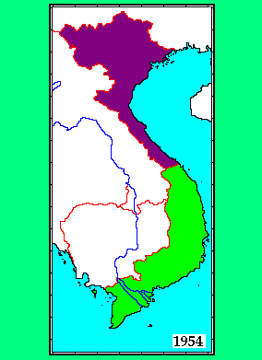

Tonkin Gulf Resolution:

Vietnam 2:

Viet Cong:

Ho Chi Minh Trail:

Strategy in Vietnam:

Robert McNamara:

Body Count:

Strategic Hamlet Program:

Who came up with the plan:

What was the objective:

Did it work? Why or why not?

Operation Rolling Thunder:

Who came up with the plan:

What was the objective:

What were the weapons used:

Did it work? Why or why not?

Search and Destroy:

Who came up with the plan:

What was the objective:

What were the weapons used:

Did it work? Why or why not?

North Vietnam Strategy:

Viet Cong Strategy:

Tet Offensive:

Results:

Hidden Result:

Vietnam on the Homefront- America turns on the war

Pentagon Papers

Draft

My Lai Massacre

Kent State Massacre

Walter Cronkite/ TV

End of the War:

Richard Nixon

Vietnamization:

January 1973:

April 1975:

Was this “peace with honor”?

Did the United States lose the Vietnam War?

