Document 1: FDR speech
Innocent peoples, innocent nations are being cruelly sacrificed to a greed for power and supremacy which is devoid of all sense of justice and humane considerations. To paraphrase a recent author, "perhaps we foresee a time when men, exultant in the technique of homicide, will rage so hotly over the world that every precious thing will be in danger, every book, every picture, every harmony, every treasure garnered through two millenniums, the small, the delicate, the defenseless—all will be lost or wrecked or utterly destroyed."
If those things come to pass in other parts of the world, let no one imagine that America will escape, that America may expect mercy, that this Western hemisphere will not be attacked and that it will continue tranquilly and peacefully to carry on the ethics and the arts of civilization....
If those days are not to come to pass—if we are to have a world in which we can breathe freely and live without fear—then the peace-loving nations must make a concerted effort to uphold laws and principles on which alone peace can rest secure.
Source: Excerpt from Franklin D. Roosevelt's "Quarantine Speech," October 5, 1937

Document 2: Churchill Speech
The other day, President Roosevelt gave his opponent in the late Presidential Election [Mr. Wendell Willkie] a letter of introduction to me, and in it he wrote out a verse, in his own handwriting, from Longfellow, which he said, “applies to you people as it does to us.” Here is the verse:
. . .Sail on, O Ship of State!
Sail on, O Union, strong and great!
Humanity with all its fears,
With all the hopes of future years,
Is hanging breathless on thy fate!
Here is the answer which I will give to President Roosevelt: Put your confidence in us. Give us your faith and your blessing, and, under Providence, all will be well. We shall not fail or falter; we shall not weaken or tire. Neither the sudden shock of battle, nor the long-drawn trials of vigilance and exertion will wear us down. Give us the tools, and we will finish the job.
Source: Excerpt from Winston Churchill’s “Give us the tools Speech, “February 9, 1941. Broadcast, London

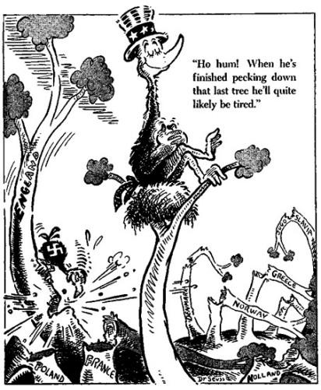
Source: Ho hum! When he's finished pecking down that last tree he'll quite likely be tired., May 22, 1941, Dr. Seuss Political Cartoons. Special Collection & Archives, UC San Diego Library

Document 4: Dr. Seuss Cartoon
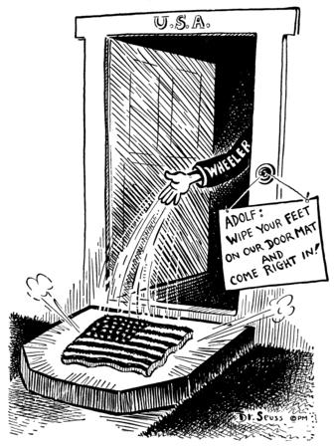
Source: Adolf: Wipe your feet on our door mat and come right in!, July 28, 1941, Dr. Seuss Political Cartoons. Special Collection & Archives, UC San Diego Library

