Andrew Carnegie
Carnegie was born in Dunfermline, the medieval capital of Scotland, in 1835. He experienced poverty during his childhood. As Carnegie described, "I began to learn what poverty meant," Andrew would later write. "It was burnt into my heart then that my father had to beg for work. And then and there came the resolve that I would cure that when I got to be a man." Andrew's mother, fearing for the economic survival of her family, pushed the family to leave the poverty of Scotland for the possibilities in America. She borrowed 20 pounds she needed to pay the fare for the Atlantic passage and in 1848 the Carnegies joined two of Margaret's sisters in Pittsburgh, then a sooty city that was the iron-manufacturing center of the country.
William Carnegie secured work in a cotton factory and his son Andrew took work in the same building as a bobbin boy for $1.20 a week. Later, Carnegie worked as a messenger boy in the city's telegraph office. He did each job to the best of his ability and seized every opportunity to take on new responsibilities. At the telegraph office, Carnegie met Thomas A. Scott, then beginning his impressive career at Pennsylvania Railroad. Scott was taken by the young worker and referred to him as "my boy Andy," hiring him as his private secretary and personal telegrapher at $35 a month. Eager to take on new responsibilities, Carnegie worked his way up the ladder in Pennsylvania Railroad and succeeded Scott as superintendent of the Pittsburgh Division.
The Civil War fueled the iron industry, and by the time the war was over, Carnegie saw the potential in the field and resigned from Pennsylvania Railroad. It was one of many bold moves that would typify Carnegie's life in industry and earn him his fortune. He then turned his attention to the Keystone Bridge Company, which worked to replace wooden bridges with stronger iron ones. In three years he had an annual income of $50,000.
Carnegie would continue making unparalleled amounts of money for the next 30 years. Two years after he wrote that letter Carnegie would embrace a new steel refining process being used by Englishman Henry Bessemer (Bessemer Process) to convert huge batches of iron into steel, which was much more flexible than brittle iron. Carnegie threw his own money into the process and even borrowed heavily to build a new steel plant near Pittsburgh. Carnegie was ruthless in keeping down costs and managed by the motto "watch costs and the profits take care of themselves."
Carnegie was unusual among the industrial captains of his day because he preached for the rights of laborers to unionize and to protect their jobs. However, Carnegie's actions did not always match his rhetoric. Carnegie's steel workers were often pushed to long hours and low wages. In the Homestead Strike of 1892, Carnegie threw his support behind plant manager Henry Frick, who locked out workers and hired Pinkerton thugs to intimidate strikers. Many were killed in the conflict, and it was an episode that would forever hurt Carnegie's reputation and haunt the man.
A proponent of vertical integration, Carnegie's steel juggernaut was unstoppable, and by 1900 Carnegie Steel produced more of the metal than all of Great Britain. That was also the year that financier J. P. Morgan mounted a major challenge to Carnegie's steel empire. While Carnegie believed he could beat Morgan in a battle lasting five, 10 or 15 years, the fight did not appeal to the 64-year old man eager to spend more time with his wife Louise, whom he had married in 1886, and their daughter, Margaret.
Carnegie wrote the asking price for his steel business on a piece of paper and had one of his managers deliver the offer to Morgan. Morgan accepted without hesitation, buying the company for $480 million. "Congratulations, Mr. Carnegie," Morgan said to Carnegie when they finalized the deal. "you are now the richest man in the world."
Fond of saying that "the man who dies rich dies disgraced," Carnegie then turned his attention to giving away his fortune. He abhorred charity, and instead put his money to use helping others help themselves. That was the reason he spent much of his collected fortune on establishing over 2,500 public libraries as well as supporting institutions of higher learning. By the time Carnegie's life was over, he gave away 350 million dollars.

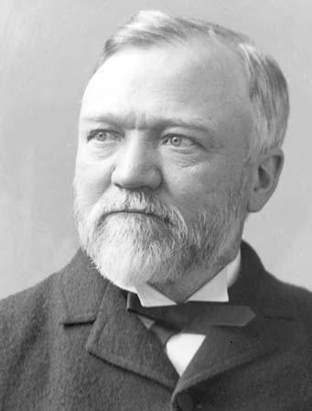

Cornelius Vanderbilt
The son of an impoverished farmer and boatman, Vanderbilt quit school at age 11 to work on the waterfront. In 1810 he purchased his first boat with money borrowed from his parents. He used the boat to ferry passengers between Staten Island and New York City. Then, during the War of 1812, he enlarged his operation to a small fleet, with which he supplied government outposts around the city.
Vanderbilt expanded his ferry operation still further following the war, but in 1818 he sold all his boats and went to work for Thomas Gibbons as steamship captain. While in Gibbons’s employ (1818–29), Vanderbilt learned the steamship business and acquired the capital that he used in 1829 to start his own steamship company. During the next decade, Vanderbilt gained control of the traffic on the Hudson River by cutting fares and offering unprecedented luxury on his ships. His hard-pressed competitors finally paid him handsomely in return for Vanderbilt’s agreement to move his operation. He then concentrated on the northeastern seaboard, offering transportation from Long Island to Providence and Boston. By 1846 the Commodore was a millionaire.
The following year, he formed a company to transport passengers and goods from New York City and New Orleans to San Francisco via Nicaragua. With the enormous demand for passage to the West Coast brought about by the 1849 gold rush, Vanderbilt’s Accessory Transit Company proved a huge success. He quit the business only after his competitors—whom he had nearly ruined—agreed to pay him $40,000 (later it rose to $56,000) a month to abandon his operation.
Vanderbilt was a pioneer of the railroad industry. When the Civil War disrupted water traffic, he invested more in railroads. By 1869, just four years after the war’s end, Vanderbilt had gained control over the New York Central Railroad and two other lines that connected the Central with New York city. He continued to add to his railroad holding. A master of horizontal integration, soon he controlled lines between Chicago, Cleveland, New York, and Toledo. Vanderbilt extended his railroad system by purchasing smaller lines. He then combined them to make direct routes between urban centers. By providing more efficient service, Vanderbilt took advantage of the growing demand for rail transportation. During the last years of his life, Vanderbilt ordered the construction of Grand Central Depot (the forerunner of Grand Central Terminal) in New York City, a project that gave jobs to thousands who had become unemployed during the Panic of 1873. Although never interested in philanthropy while acquiring the bulk of his huge fortune, later in his life he did give $1 million to Central University in Nashville, Tennessee. (later Vanderbilt University). At the time of his death in 1877, Vanderbilt controlled more than 4500 miles of railroad track. His personal fortune was estimated at $100 million.
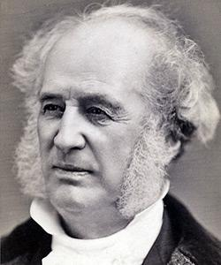

John D. Rockefeller
Rockefeller was born in 1839 in Moravia, a small town in western New York. His father practiced herbal medicine, professing to cure patients with remedies he had created from plants in the area. John's mother instilled a devout Baptist faith in the boy, a belief system he took to his grave. After being graduated from high school in 1855, the family sent him to a Cleveland business school. Young John Rockefeller entered the workforce on the bottom rung of the ladder as a clerk in a Cleveland shipping firm. Always thrifty, he saved enough money to start his own business in produce sales. When the Civil War came, the demand for his goods increased dramatically, and Rockefeller found himself amassing a small fortune.
He took advantage of the loophole in the Union draft law by purchasing a substitute to avoid military service. When Edwin drake discovered oil in 1859 in Titusville, Pennsylvania, Rockefeller saw the future. He slowly sold off his other interests and became convinced that refining oil would bring him great wealth.
Rockefeller was a master of vertical integration and he introduced techniques that totally reshaped the Oil Industry. In the mid-19th century, the chief demand was for kerosene. In the refining process, there are many by-products when crude oil is converted to Kerosene. What others saw as waste, Rockefeller saw as gold. He sold one byproduct, paraffin, to candle makers and another byproduct petroleum jelly to medical supply companies. He even sold off other "waste" as paving materials for roads. He shipped so many goods that railroad companies drooled over the prospect of getting his business.
Rockefeller demanded Rebates, or discounted rates, from the railroads. He used all these methods to reduce the price of oil to his consumers. His profits soared and his competitors were crushed one by one. Rockefeller forced smaller companies to surrender their stock to his control. He used horizontal integration to build a trust. A TRUST is a combination of firms formed by legal agreement. Trusts often reduce fair business competition. As a result of Rockefeller's shrewd business practices, his large corporation, the Standard Oil Company, became the largest business in the land.
As the new century dawned, Rockefeller's investments mushroomed. With the advent of the automobile, gasoline replaced kerosene as the number one petroleum product. Rockefeller was a bona fide billionaire. Critics charged that his labor practices were unfair. Employees pointed out that he could have paid his workers a fairer wage and settled for being a half-billionaire. Before his death in 1937, Rockefeller gave away nearly half of his fortune. Churches, medical foundations, universities, and centers for the arts received hefty sums of oil money. Whether he was driven by good will, conscience, or his devout faith in God is unknown. Regardless, he became a hero to many enterprising Americans.
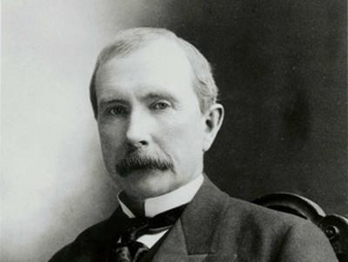

JP Morgan
Not all of the tycoons of the Gilded Age were rags-to-riches stories. J. Pierpont Morgan was born into a family of great wealth. His father had already made a name for himself in the banking industry. With Morgan's family resources, he enjoyed the finest business education money could buy. He did not scratch and claw his way to the top of any corporate ladder. His father arranged for an executive track position at one of New York's finest banks. Regardless of his family's advantages, Morgan had a great mind of his own. He set out to conquer the financial world, and conquer it he did.

Morgan's first business ventures were in banking. By 1860, he had already established his own foreign exchange office. He knew the power of investment. Not content to control just the banking industry, he bought many smaller ventures to make money. During the Civil War, he paid the legally allowed fee to purchase a substitute soldier and evaded military service. Morgan made handsome profits by providing war materials. One of his enterprises sold defective rifles to the Union army. Upon later investigations, he was declared ignorant of the poor quality of his guns and was cleared of all charges.

After the war, he set out to corner the nation's financial markets. When the Panic of 1873 rocked the nation's economy, Morgan protected himself wisely and emerged in the aftermath as the king of American finance. Despite his label as a robber baron, Morgan felt his investments benefited America. His railroad dealings helped consolidate many smaller, mismanaged firms, resulting in shorter trips and more dependable service. Two times during financial panics he allowed the federal government to purchase his vast gold supplies to stop the spiral of deflation.

He owned a bridge company and a tubing company. His most renowned purchase was in 1901, when he bought the Carnegie Steel Company for $500 million to create U.S. Steel. Within ten years U.S. Steel was worth over a billion dollars. Morgan's actions marked a shift in thinking among American industrialists. He proved that it was not necessary to be a builder to be successful. Smart investment and efficient consolidation could yield massive profits. Young entrepreneurs shifted their goals to banking in the hopes of mirroring Morgan's success.
For all his accomplishments, he was harshly criticized. The first decade of the twentieth century brought challenges to Morgan from the government. His Northern Securities Railroad company was deemed illegal under federal antitrust law, the first such action by the national government. He was investigated by Congress for his control of the financial markets. Even U.S. Steel was forced to relinquish its monopoly.

Jaded by the criticism, Morgan moved to Europe, where he lived his final days. He was a favorite target of intellectuals who claimed that such tycoons robbed the poor of their deserved wealth. He was a hero to enterprising financiers across the land who dreamed of following his example. That is, of course, unless they were destroyed by his shrewd, fierce tactics.
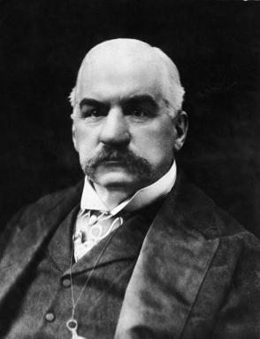

Henry Ford

Famed automobile manufacturer Henry Ford was born on July 30, 1863, on his family's farm in Wayne County, near Dearborn, Michigan. When Ford was 13 years old, his father gifted him a pocket watch, which the young boy promptly took apart and reassembled. Friends and neighbors were impressed, and requested that he fix their timepieces too.

Unsatistfied with farm work, Ford left home the following year, at the age of 16, to take an apprenticeship as a machinist in Detroit. In the years that followed, he would learn to skillfully operate and service steam engines, and would also study bookkeeping. In 1888, Ford married Clara Ala Bryant and briefly returned to farming to support his wife and son, Edsel. But three years later, he was hired as an engineer for the Edison Illuminating Company. In 1893, his natural talents earned him a promotion to chief engineer. All the while, Ford developed his plans for a horseless carriage, and in 1896, he constructed his first model, the Ford Quadricycle. Within the same year, he attended a meeting with Edison executives and found himself presenting his automobile plans to Thomas Edison. The lighting genius encouraged Ford to build a second, better model.

After a few trials building cars and companies, in 1903, Henry Ford established the Ford Motor Company. Ford introduced the Model T in October of 1908, and for several years, the company posted 100 percent gains. However, more than for his profits, Ford became renowned for his revolutionary vision: the manufacture of an inexpensive automobile made by skilled workers who earn steady wages.

In 1914, he sponsored the development of the moving assembly line technique of mass production. This was a version of Scientific Management that limited waste and increased efficiency. Simultaneously, he introduced the $5-per-day wage ($110 in 2011) as a method of keeping the best workers loyal to his company. Simple to drive and cheap to repair, half of all cars in America in 1918 were Model T's.

From a social perspective, Henry Ford's was marked by seemingly contradictory viewpoints. In business, Ford offered profit sharing to select employees who stayed with the company for six months and, most important, who conducted their lives in a respectable manner. The company's "Social Department" looked into an employee’s drinking, gambling and otherwise uncouth activities to determine eligibility for participation. Ford was also an ardent pacifist and opposed World War I, even funding a peace ship to Europe. Later, in 1936, Ford and his family established the Ford Foundation to provide ongoing grants for research, education and development. But despite these philanthropic leanings, Ford was also a committed anti-Semite, going as far as to support a weekly newspaper, The Dearborn Independent, which furthered such views.

Henry Ford died of a cerebral hemorrhage on April 7, 1947, at the age of 83, near his Dearborn estate, Fair Lane. Ford, considered one of America's leading businessmen, is credited today for helping to build America's economy during the nation's vulnerable early years. His legacy will live on for decades to come.

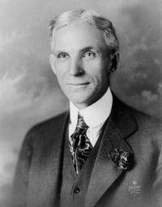

Alexander Graham Bell:
Alexander Graham Bell was born on March 3, 1847, in Edinburgh, Scotland. During his youth, Alexander Graham Bell experienced strong influences that had a profound effect on his later life. His grandfather and father were experts on the mechanics of voice and elocution. Alexander’s mother, who was nearly deaf, became an accomplished pianist and inspired him to undertake big challenges.
By age 16, Alexander had joined his father in his work with the deaf and soon assumed full charge of his father’s London operations. On one of his trips to America, Alexander’s father discovered its healthier environment and decided to move the family there. In July, 1870, the family settled in Brantford, Ontario, Canada. There, Alexander set up a workshop to continue his study of the human voice.
In 1871, Alexander Graham Bell moved to Boston and began work on a device that would allow for the telegraph transmission of several messages set to different frequencies. Between 1873 and 1874, Bell spent long days and nights trying to perfect the harmonic telegraph. During his experiments, he became interested in another idea, transmitting the human voice over wires. Through 1874 and 1875, Bell labored on both the harmonic telegraph and a voice transmitting device. On March 10, 1876, Bell was successful in transmitting the first telephone call.
With this success, Alexander Graham Bell began to promote the telephone in a series of public demonstrations. At the Centennial Exhibition in Philadelphia, in 1876, Bell demonstrated the telephone to the Emperor of Brazil, Dom Pedro, who exclaimed, “My God, it talks!” Other demonstrations followed, each at a greater distance than the last. The Bell Telephone Company was organized on July 9, 1877.
The company grew quickly and significantly. Between 1877 and 1886, over 150,000 people in the U.S. owned telephones. Improvements were made on the device including the addition of a microphone, invented by Thomas Edison, which eliminated the need to shout into the telephone to be heard.
In 1880, Bell established the Volta Laboratory, an experimental facility devoted to scientific discovery. He also continued his work with the deaf, establishing the American Association to Promote Teaching of Speech to the Deaf in 1890.
In January 1915, Bell was invited to make the first transcontinental phone call. From New York, he spoke with his former associate Thomas Watson in San Francisco. Bell died peacefully with his wife by his side in Baddeck, Nova Scotia, Canada, on August 2, 1922. The entire telephone system was shut down for one minute in tribute to his life.
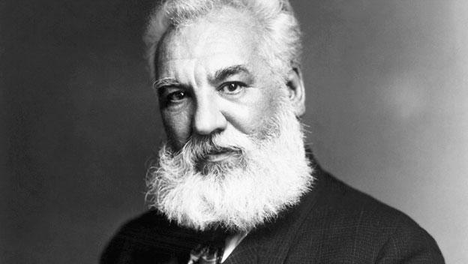

Thomas Edison
Thomas Alva Edison was born February 11, 1847 in Milan, Ohio (pronounced MY-lan). In 1854, when he was seven, the family moved to Michigan, where Edison spent the rest of his childhood. "Al," as he was called as a boy, went to school only a short time. He did so poorly that his mother, a former teacher, taught her son at home. Al learned to love reading, a habit he kept for the rest of his life. He also liked to make experiments in the basement.
At 15, Al roamed the country as a "tramp telegrapher." Using a kind of alphabet called Morse Code, he sent and received messages over the telegraph. Even though he was already losing his hearing, he could still hear the clicks of the telegraph. In the next seven years he moved over a dozen times, often working all night, taking messages for trains and even for the Union Army during the Civil War. In his spare time, he took things apart to see how they worked. Finally, he decided to invent things himself.
After the failure of his first invention, the electric vote recorder, Edison moved to New York City. There he improved the way the stock ticker worked. This was his big break. By 1870 his company was manufacturing his stock ticker in Newark, New Jersey. He also improved the telegraph, making it send up to four messages at once.

Wanting a quieter spot to do more inventing, Edison moved from Newark to Menlo Park, New Jersey, in 1876. There he built his most famous laboratory. He was not alone in Menlo Park. Edison hired "muckers" to help him out. These "muckers" came from all over the world to make their fortune in America. They often stayed up all night working with the "chief mucker," Edison himself. He is sometimes called the "Wizard of Menlo Park" because he created two of his three greatest works there.

The phonograph was the first machine that could record the sound of someone's voice and play it back. In 1877, Edison recorded the first words on a piece of tin foil. He recited the nursery rhyme "Mary Had a Little Lamb," and the phonograph played the words back to him. This was invented by a man whose hearing was so poor that he thought of himself as "deaf"! Starting in 1878, Edison and the muckers worked on one of his greatest achievements. The electric light system was more than just the incandescent lamp, or "light bulb." Edison also designed a system of power plants that make the electrical power and the wiring that brings it to people's homes.
Edison built a laboratory in West Orange that was ten times larger than the one in Menlo Park. In fact, it was one of the largest laboratories in the world, almost as famous as Edison himself. Well into the night, laboratory buildings glowed with electric light while the Wizard and his "muckers" turned Edison's dreams into inventions. Once, the "chief mucker" worked for three days straight, taking only short naps. Edison earned half of his 1,093 patents in West Orange. But Edison did more than invent. Here Edison could think of ways to make a better phonograph, for example, build it with his muckers, have them test it and make it work, then manufacture it in the factories that surrounded his laboratory. This improved phonograph could then be sold throughout the world.
Not only did Edison improve the phonograph several times, but he also worked on X-rays, storage batteries, and the first talking doll. At West Orange he also worked on one of his greatest ideas: motion pictures, or "movies." The inventions made here changed the way we live even today. He worked here until his death on October 18, 1931, at the age of 84.
By that time, everyone had heard of the "Wizard" and looked up to him. The whole world called him a genius. But he knew that having a good idea was not enough. It takes hard work to make dreams into reality. That is why Edison liked to say, "Genius is 1% inspiration and 99% perspiration."

