Objective 3: Amphibious invasion, control the beaches.
- The Beaches
The Allies wanted to establish a major beach-head on the coast of Occupied France, thereby initiating a campaign against German forces in Western Europe designed to liberate all occupied countries, and to invade and conquer Germany itself.
Five specific landing zones were selected and given names; Gold Beach, Sword Beach, Omaha Beach, Juno Beach, and Utah Beach.
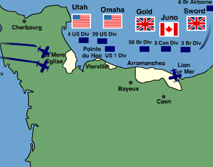

Objective 3: Amphibious invasion, control the beaches.
- The Transports
The Allied forces expected to meet heavy German defenses in the area and built up a landing force of nearly 160,000 troops transported by some 7,000 vessels to combat the Germans. The numbers of forces and equipment involved in the assault made Operation Overlord the largest amphibious invasion in world history.
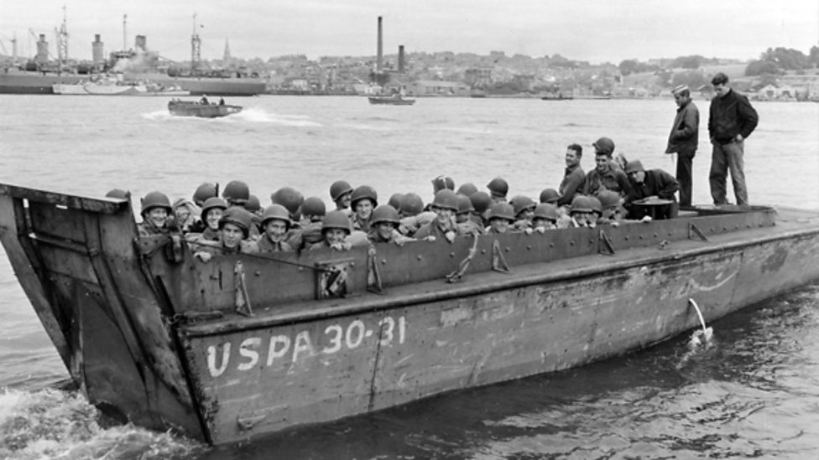

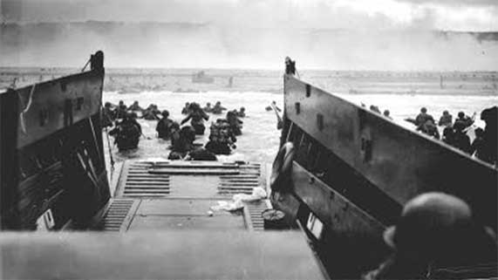
Objective 3: Amphibious invasion, control the beaches.
- First Beach Scene:
Even to Land Was a Miracle: Sprawling Bodies Tell Mute Story of Death in the Murderous Fire by Ernie Pyle
(printed in The Stars and Stripes on Monday, June 12, 1944)

Due to last-minute arrangements I didn't arrive at the beachhead until the morning after D-Day, after our first wave of assault troops had hit the shore. By the time we got here the beaches had been taken and the fighting had moved a couple of miles inland. All that remained on the beach were some sniper and artillery fire and an occasional startling blast of a mine geysering brown sand into the air.

That, plus a gigantic and pitiful litter of wreckage along miles of the shore line. Submerged tanks and upturned boats and burned trucks and shell-shattered jeeps and the sad little personal belongings strewn forever on these bitter sands.

That, plus bodies of soldiers lying in rows covered with blankets, the toes of their shoes sticking up in a line as though on drill. And other uncollected bodies still sprawling grotesquely in the sand or half-hidden by high grass behind the beach.

That, plus an intense grim determination of work-weary men to get the chaotic beach organized and get the all-vital supplies and reinforcements moving more rapidly over it from the stacked-up ships standing in droves out to sea.

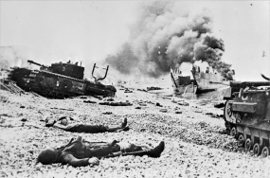

Objective 3: Amphibious invasion, control the beaches.
- The Struggle:
Even to Land Was a Miracle: Sprawling Bodies Tell Mute Story of Death in the Murderous Fire by Ernie Pyle
(printed in The Stars and Stripes on Monday, June 12, 1944)

In this column I want to tell you what the opening of the Second Front in this one sector entailed so that you can know and appreciate and forever be humbly grateful to those both dead and alive who did it for you.

Ashore facing us were more enemy troops than we had in our assault waves. The advantages were all theirs, disadvantages all ours. The Germans were dug into positions they had been working on for months. Still they were not yet all complete. One hundred-foot bluff a couple of hundred yards back from the beach had great concrete gun emplacements built right into the hilltops. They opened to the sides instead of the front, thus making it very hard for naval fire from the sea to reach them. They could shoot parallel with the beach and cover every foot of it for miles with artillery fire. Then they had hidden mine-gun nests on the forward slopes with crossfire taking every inch of the beach. These nests connected networks of trenches so that German gunners could move about without exposing themselves.

Throughout the length of the beach, running zigzag a couple of hundred yards back from the shoreline, was an immense V-shaped ditch, 15 feet deep. Nothing could cross it, not even men afoot, until hills had been made. And in other places, at the far ends of the beach, where the ground was flatter they had great concrete walls which had been blasted by naval gunfire, or by hand set explosives after we got ashore. Our only exits from the beach were several swails or valleys, each about 100 yards wide. The Germans made the most of these funnel-like traps, literally sowing their bottom sides with buried mines. They connected to barbed-wire entanglements with mines attached, hidden duciles and machine-guns firing from the slopes.

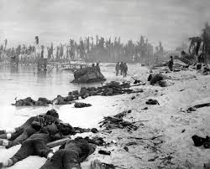
Objective 3: Amphibious invasion, control the beaches.
- The Results:
Even to Land Was a Miracle: Sprawling Bodies Tell Mute Story of Death in the Murderous Fire by Ernie Pyle
(printed in The Stars and Stripes on Monday, June 12, 1944)

That is what was on the shore. But our men had to go through a maze nearly as deadly before they even got ashore. The underwater obstacles were terrific. The Germans had whole fields of evil devices under the water to catch our boats. Even now, several days after the landings, we have cleared only channels through them, and cannot yet approach the whole length of the beach with our ships. Even now a ship or boat hits one of these mines every day and is knocked out of commission. The Germans had masses of those great six-pronged "spiders" made of railroad iron and standing shoulder high in places just beneath the surface of the water for our landing craft to run into. They also had huge logs, buried in the sand pointing upward and outward, their tops just below the water. And attached to these logs were mines.

Our first waves were on that beach for hours instead of a few minutes before they could begin working inland. Men were killed as they stepped out of the landing craft. An officer whom I know got a bullet right through the head just as the door of his landing craft was let down. Some were drowned. The first crack of the beach defense was finally accomplished by terrific and wonderful naval gunfire which knocked in the big emplacements. They tell epic stories of destroyers that ran right up into shallow water' and had it out point blank with the big guns in those concrete emplacements ashore.

When the heavy fire stopped our men were organized by their officers and pushed on inland, circling machine-gun nests and taking them from the rear. And so we took that beach and accomplished our landing. We did it with every advantage on the enemy's side and every disadvantage on ours. In the light of a couple of days' retrospection we sit and talk, and call it a miracle that we ever got on at all or that we were able to stay on.

Now that it is over, it seems to me a pure miracle we ever took the beach at all. For some it was easy, but in this special sector where I now am our troops faced such odds that our getting ashore was like me whipping Joe Louis down to pulp.

