Montgomery Bus Boycott:
In the 1950s the National Association for the Advancement of Colored People was involved in the struggle to end segregation on buses and trains. In 1952 segregation on inter-state railways was declared unconstitutional by the Supreme Court. This was followed in 1954 by a similar judgment concerning interstate buses. However, states in the Deep South continued their own policy of transport segregation. This usually involved whites sitting in the front and blacks sitting nearest to the front had to give up their seats to any whites that were standing.
On 1st December, 1955, Rosa Parks, a middle-aged tailor's assistant from Montgomery, Alabama, who was tired after a hard day's work, refused to give up her seat to a white man. This resulted in her arrest. After her arrest, Martin Luther King, a pastor at the local Baptist Church, helped organize protests against bus segregation. The group was persuaded by JoAnn Robinson, of the Women's Political Council, that they should launch a bus boycott. The idea being that the black people in Montgomery should refuse to use the buses until passengers were completely integrated. King was arrested and his house was fire-bombed. Others involved in the Montgomery Bus Boycott also suffered from harassment and intimidation, but the protest continued.
For thirteen months the 17,000 black people in Montgomery walked to work or obtained lifts from the small car-owning black population of the city. Eventually, the loss of revenue and a decision by the Supreme Court on 13th November, 1956, forced the Montgomery Bus Company to accept integration. The following month the buses in Montgomery were desegregated.
The 1964 Civil Rights Act made racial discrimination in public places, such as theaters, restaurants and hotels, illegal. It also required employers to provide equal employment opportunities. Projects involving federal funds could now be cut off if there was evidence of discriminated based on color, race or national origin.
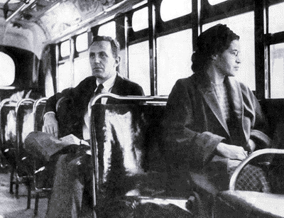
Sit-In Movement:
On 1st February, 1960, Franklin McCain, David Richmond, Joseph McNeil and Ezell Blair, started a student sit-in at the restaurant of their local Woolworth's store which had a policy of not serving black people. In the days that followed they were joined by other black students until they occupied all the seats in the restaurant. The students were often physically assaulted, but following the teachings of King they did not hit back.
Later that month about forty college students staged a sit-in at Woolworth's lunch counter in Nashville, Tennessee. Their numbers increased daily and although hundreds were arrested, by May, lunch counters in Nashville began to integrate.
This non-violent strategy was adopted by black students all over the Deep South. Within six months these sit-ins had ended restaurant and lunch-counter segregation in twenty-six southern cities. Student sit-ins were also successful against segregation in public parks, swimming pools, theaters, churches, libraries, museums and beaches.
In October, 1960, students involved in these sit-ins held a conference and established the Student Nonviolent Coordinating Committee (SNCC). The organization adopted the theory of nonviolent direct action. The campaign to end segregation at lunch counters in Birmingham, Alabama, was less successful. In the spring of 1963 police turned dogs and fire hoses on the demonstrators. King and large number of his supporters, including schoolchildren, were arrested and jailed.
The 1964 Civil Rights Act made racial discrimination in public places, such as theaters, restaurants and hotels, illegal. It also required employers to provide equal employment opportunities. Projects involving federal funds could now be cut off if there was evidence of discriminated based on color, race or national origin.
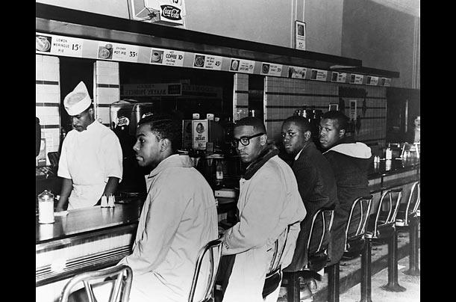

Freedom Riders:
In the 1950s the National Association for the Advancement of Colored People was involved in the struggle to end segregation on buses and trains. In 1952 segregation on inter-state railways was declared unconstitutional by the Supreme Court. However, states in the Deep South continued their own policy of transport segregation. This usually involved whites sitting in the front and blacks giving up their seats to white passengers.
Transport segregation continued in some parts of the United States, so in 1961, a civil rights group, the Congress on Racial Equality (CORE) began to organize Freedom Rides. After three days of training in non-violent techniques, black and white volunteers sat next to each other as they travelled through the Deep South. The Freedom Riders were split between two buses. They travelled in integrated seating and visited "white only" restaurants. When they reached Anniston on 14th May the Freedom Riders were attacked by men armed with clubs, bricks, iron pipes and knives. One of the buses was fire-bombed and the mob held the doors shut, intent on burning the riders to death.
James Peck later explained what happened: "When the Greyhound bus pulled into Anniston, it was immediately surrounded by an angry mob armed with iron bars. They set about the vehicle, denting the sides, breaking windows, and slashing tires. Finally, the police arrived and the bus managed to depart. But the mob pursued in cars. Within minutes, the pursuing mob was hitting the bus with iron bars. The rear window was broken and a bomb was hurled inside. All the passengers managed to escape before the bus burst into flames and was totally destroyed. Policemen, who had been standing by, belatedly came on the scene. A couple of them fired into the air. The mob dispersed and the injured were taken to a local hospital."
The surviving bus travelled to Birmingham, Alabama. A meeting of Student Nonviolent Coordinating Committee (SNCC) at Fisk University in Nashville, Tennessee decided to send reinforcements. The volunteers realized their mission was extremely dangerous. The Freedom Riders now traveled onto Montgomery, Alabama. In Montgomery, the passengers were attacked by a large mob. They were dragged from the bus and beaten by men with baseball bats and lead piping. Taylor Branch, the author of Parting the Waters: America in the King Years, 1954-63 (1988) wrote: "One of the men grabbed Zwerg's suitcase and smashed him in the face with it. Others slugged him to the ground, and when he was dazed beyond resistance, one man pinned Zwerg's head between his knees so that the others could take turns hitting him. As they steadily knocked out his teeth, and his face and chest were streaming blood, a few adults on the perimeter put their children on their shoulders to view the carnage." James Zwerg, who was badly beaten-up claimed from his hospital bed: "Segregation must be stopped. It must be broken down. Those of us on the Freedom Ride will continue. No matter what happens we are dedicated to this. We will take the beatings. We are willing to accept death. We are going to keep coming until we can ride anywhere in the South."
During the summer of 1961 freedom riders also campaigned against other forms of racial discrimination. They sat together, in segregated restaurants, lunch counters and hotels. This was especially effective when it concerned large companies who, fearing boycotts in the North, began to desegregate their businesses.
Robert Kennedy petitioned the Interstate Commerce Commission (ICC) to draft regulations to end racial segregation in bus terminals. As with the Montgomery Bus Boycott and the conflict at Little Rock, the Freedom Riders gave world publicity to the racial discrimination suffered by African Americans, and in doing so, helped to bring about change. The 1964 Civil Rights Act made racial discrimination in public places, such as theaters, restaurants and hotels, illegal. It also required employers to provide equal employment opportunities. Projects involving federal funds could now be cut off if there was evidence of discriminated based on colour, race or national origin.

Birmingham Campaign:
The Birmingham campaign was a strategic movement organized by the Southern Christian Leadership Conference (SCLC) to bring attention to the unequal treatment that black Americans endured in Birmingham, Alabama. The campaign ran during the spring of 1963, culminating in widely publicized confrontations between black youth and white civic authorities that eventually pressured the government to change the city's discrimination laws. Organizers, led by Martin Luther King, Jr. used nonviolent direct action tactics to defy laws they considered unfair.
In the early 1960s, Birmingham was one of the most racially divided cities in the United States, as black citizens faced legal and economic disparities as well as violent retribution when they attempted to bring attention to their problems. Protests in Birmingham began with a boycott to pressure business leaders to provide employment opportunities to people of all races, and end segregation in public facilities, restaurants, and stores. When business leaders resisted the boycott, SCLC organizer Wyatt Tee Walker and Birmingham native Fred Shuttlesworth began what they termed Project C, a series of sit-ins and marches intended to provoke mass arrests. After the campaign ran low on adult volunteers, high school, college, and elementary students were trained by SCLC coordinator James Bevel to participate, resulting in hundreds of arrests and an instant intensification of national media attention on the campaign. To dissuade demonstrators and control the protests the Birmingham Police Department, led by Eugene "Bull" Connor, used high-pressure water jets and police dogs on children and bystanders. Media coverage of these events brought intense scrutiny on racial segregation in the South.
Scenes of the ensuing mayhem caused an international outcry, leading to federal intervention by the Kennedy administration. By the end of the campaign, King's reputation surged, the "Jim Crow" signs in Birmingham came down, and public places became more open to blacks.
The Birmingham campaign was a model of direct action protest, as it effectively shut down the city. By attracting media attention to the adverse treatment of black Americans, it brought national force to bear on the issue of segregation. Although desegregation occurred slowly in Birmingham, the campaign was a major factor in the national push towards the Civil Rights Act of 1964, which prohibited racial discrimination in hiring practices and public services in the United States.
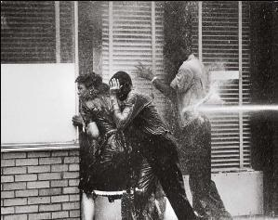
March on Washington
The March on Washington for Jobs and Freedom, sometimes referred to as “The Great March on Washington", was one of the largest political rallies for human rights in United States history. The goal of the march was to bring attention to the civil and economic rights of African Americans. The Southern Christian Leadership Committee joined with the Congress of Racial Equality to organize the famous March on the nation’s capital. Bayard Rustin was given overall control of the march and he managed to persuade the leaders of all the various civil rights groups to participate in the planned protest meeting at the Lincoln Memorial.
The march took place in Washington, D.C. on Wednesday, August 28, 1963. More than 2,000 buses, 21 special trains, 10 chartered airliners, and uncounted cars converged on Washington. All regularly scheduled planes, trains, and buses were also filled to capacity. The march began at the Washington Monument and ended at the Lincoln Memorial with a program of music and speakers. Estimates of the number of participants varied from 200,000 to 300,000. Observers estimated that 75–80% of the marchers were black and the rest were white and non-black minorities.
During the event, Martin Luther King, Jr., standing in front of the Lincoln Memorial, delivered his historic "I Have a Dream" speech advocating racial harmony. Media attention gave the March national exposure, carrying the organizers' speeches and offering their own commentary.
The march is widely credited with helping to pass the two most significant Civil Rights Acts since reconstruction (the Civil Rights Act (1964) and the Voting Rights Act (1965). The 1964 Civil Rights Act made racial discrimination in public places, such as theaters, restaurants and hotels, illegal. On 6th August, 1965, Lyndon B. Johnson signed the Voting Rights Act. This removed the right of states to impose restrictions on who could vote in elections. The legislation now empowered the national government to register those whom the states refused to put on the voting list.

Freedom Summer:
In 1964 the Congress on Racial Equality (CORE), Student Nonviolent Coordinating Committee (SNCC) and the National Association for the Advancement of Colored People (NAACP) organized its Freedom Summer campaign. Directed by Robert Moses, its main objective was to try an end the political disenfranchisement of African Americans in the Deep South. Volunteers from the three organizations decided to concentrate its efforts in Mississippi. In 1962 only 6.7 per cent of African Americans in the state were registered to vote, the lowest percentage in the country. This involved the formation of the Mississippi Freedom Party (MFDP). Over 80,000 people joined the party and 68 delegates, led by Fannie Lou Hamer, attended the Democratic Party Convention in Atlantic City and challenged the attendance of the all-white Mississippi representation.
CORE, SNCC and NAACP also established 30 Freedom Schools in towns throughout Mississippi. Volunteers taught in the schools and the curriculum now included black history, the philosophy of the civil rights movement. During the summer of 1964 over 3,000 students attended these schools and the experiment provided a model for future educational programs such as Head Start.
Freedom Schools were often targets of white mobs. So also were the homes of local African Americans involved in the campaign? That summer 30 black homes and 37 black churches were firebombed. Over 80 volunteers were beaten by white mobs or racist police officers and three men, James Chaney, Andrew Goodman and Michael Schwerner, were murdered by the Ku Klux Klan on 21st June, 1964. This attempt to frighten others from joining the campaign failed and by late 1964 over 70,000 students had taken part in Freedom Summer.
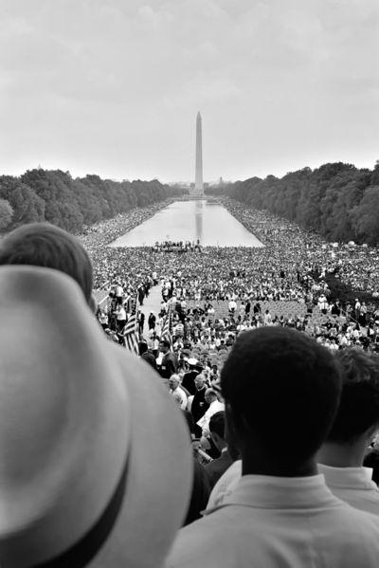
The following year, President Lyndon Baines Johnson attempted to persuade Congress to pass his Voting Rights Act. This proposed legislation removed the right of states to impose restrictions on who could vote in elections. Johnson explained how: "Every American citizen must have an equal right to vote. Yet the harsh fact is that in many places in this country men and women are kept from voting simply because they are Negroes." Although opposed by politicians from the Deep South, the Voting Rights Act was passed by large majorities in the House of Representatives (333 to 48) and the Senate (77 to 19). The legislation empowered the national government to register those whom the states refused to put on the voting list.

Selma March
After the murder of Jimmie Lee Jackson during the voter registration drive by the Student Nonviolent Coordinating Committee (SNCC) it was decided to dramatize the need for a federal registration law. With the help of Martin Luther King and Ralph David Abernathy of the Southern Christian Leadership Conference (SCLC), leaders of the SCCC organized a protest march from Selma to the state capitol building in Montgomery, Alabama. The first march on 1st February, 1965, led to the arrest of 770 people. A second march on 7th March was attacked by mounted police. The sight of state troopers using nightsticks and tear gas was filmed by television cameras and the event became known as Bloody Sunday.
Martin Luther King led another march of 1,500 people two days later. After crossing the Pettus Bridge the marchers were faced by a barricade of state troopers. King disappointed many of his younger followers when he decided to turn back in order to avoid a confrontation with the troopers. Soon afterwards, one of white ministers on the march, James J. Reeb, was murdered.
President Lyndon B. Johnson now decided to take action and sent troops, marshals and FBI Agents to protect the protesters. On Thursday, 25th March, King led 25,000 people to the Alabama State Capitol and handed a petition to Governor George Wallace, demanding voting rights for African Americans. That night, the Ku Klux Klan killed Viola Liuzzo while returning from the march.
On 6th August, 1965, Lyndon B. Johnson signed the Voting Rights Act. This removed the right of states to impose restrictions on who could vote in elections. Johnson explained how: "Every American citizen must have an equal right to vote. Yet the harsh fact is that in many places in this country men and women are kept from voting simply because they are Negroes." The legislation now empowered the national government to register those whom the states refused to put on the voting list.

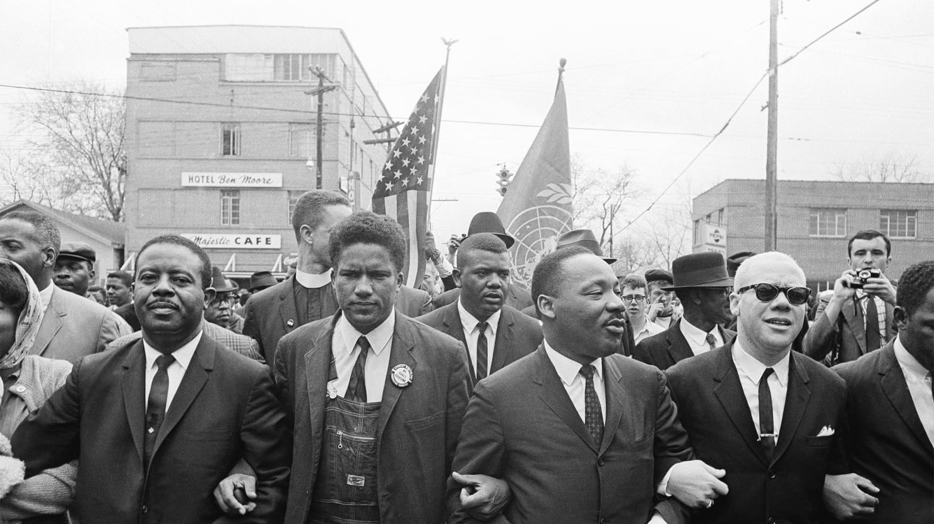

Civil Rights Organizations

SCLC –( Southern Christian Leadership Conference) The SCLC was an alliance of church-based African American organizations dedicated to ending discrimination. It was led by Martin Luther King Junior, who used nonviolent resistance in its protests. King called this technique “Confronting the forces of hate with the power of love.”

SNCC – (Student Nonviolent Coordinating Committee) The SNCC was an association of student activists from throughout the South. They were committed to nonviolence. Students were beaten by mobs and food was dumped on them during sit-ins. There was little help from local authorities. Their tactics were effective: soon many restaurants across the South were integrated.

CORE – (Congress of Racial Equality) A Northern-based civil rights group with the goal to launch nonviolent protests against racial discrimination. CORE sent integrated groups on the Freedom Ride bus trips through the South. The objective of CORE was to draw attention to violations of the Supreme Court Ruling.

COFO – (Council of Federated Organizations) COFO would coordinate voter registration drives. Many African Americans were afraid to vote because of the harassment- many had been beaten or shot. COFO Introduced many African Americans to voting procedures and showed the interest that they had in exercising their rights.

