PENTAGON PAPERS:
The Pentagon Papers was the name given to a secret Department of Defense study of U.S. political and military involvement in Vietnam from 1945 to 1967, prepared at the request of Secretary of Defense Robert McNamara in 1967. As the Vietnam War dragged on and the U.S. military presence in South Vietnam increased to more than 500,000 troops by 1968, the military analyst Daniel Ellsberg (who had worked on the study) came to oppose the war, and decided that the information contained in the Pentagon Papers should be more widely available to the American public. He secretly photocopied the report and in March 1971 gave the copy to The New York Times, which subsequently published a series of articles based on the report’s findings. Amid the national and international uproar that followed, the federal government tried unsuccessfully to block publication of the Pentagon Papers on grounds of national security.

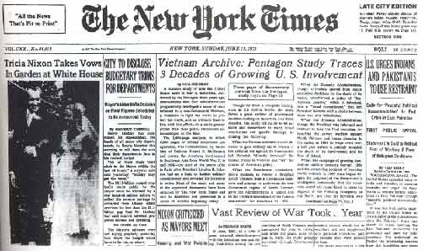

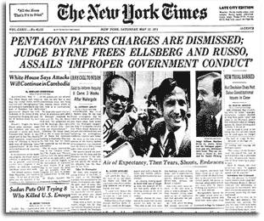

THE DRAFT:

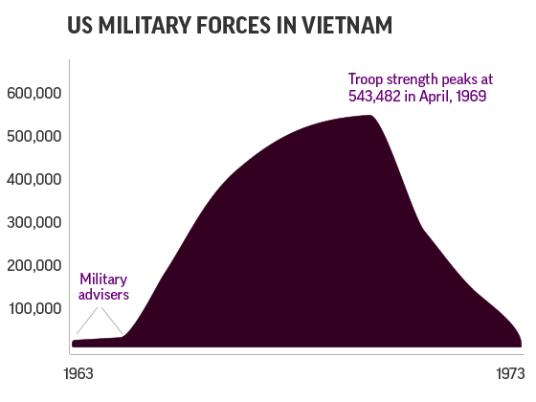
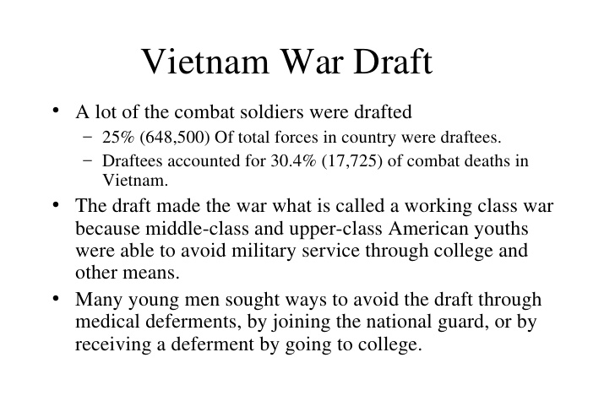
- The average age of a drafted U.S. soldier was 19 years old, which was too young to vote in an election. The 26th amendment was passed in 1971 to lower the voting age to 18 years old.
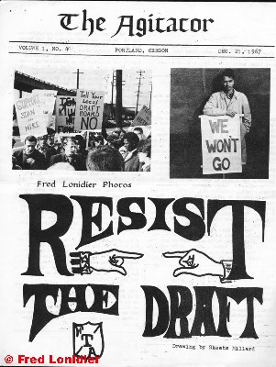

MY LAI MASSACRE:
My Lai is the site of the massacre of 340-500 unarmed civilians by “Charlie” company of U.S. soldiers on March 16, 1968.
The massacre was covered up (original report said “U.S. infantrymen had killed 128 Communists in a bloody day-long battle”) until the following year when the story was leaked to members of Congress and the press.
“In all my years in the army I was never taught that Communists were human beings. We were there to kill ideology carried by—I don’t know—pawns, blobs, pieces of flesh. I was there to destroy Communism. We never conceived of old people, men, women, children, babies”
Lt. William Calley
(only soldier prosecuted for events at My Lai)

Published in 1999, The Forgotten Hero of My Lai: The Hugh Thompson Story is the account of the My Lai massacre according to Hugh Thompson, author Trent Angers
Thompson landed his helicopter and dismounted. Sergeant David Mitchell (Squad Leader, 1st Platoon, C Company) walked over to him. When asked by Thompson whether any help could be provided to the people in the ditch, the sergeant replied that the only way to help them was to put them out of their misery. 2nd Lt. William Calley (1st Platoon Commander, C Company) then came up, and the two had the following conversation:
Thompson:: What's going on here, lieutenant?
Calley:: This is my business.
Thompson:: What is this? Who are these people?
Calley:: Just following orders.
Thompson:: Orders? Whose orders?
Calley:: Just following...
Thompson:: But, these are human beings, unarmed civilians, sir.
Calley:: Look Thompson, this is my show. I'm in charge here. It ain't your concern.
Thompson:: Yeah, great job.
Calley:: You better get back in that chopper and mind your own business.
Thompson:: You ain't heard the last of this!

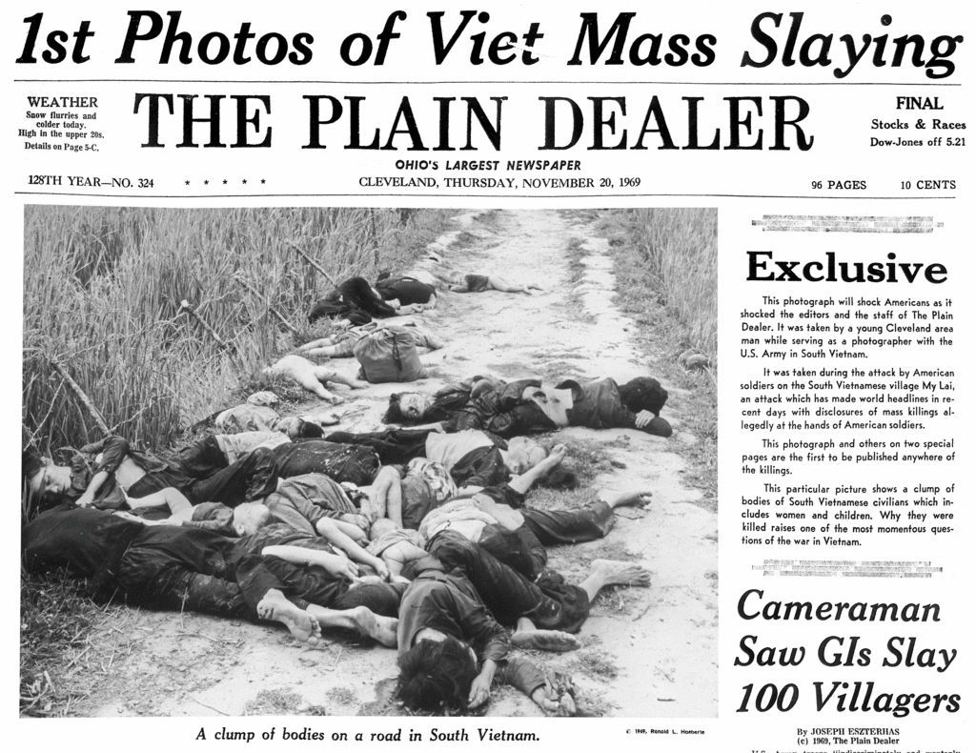
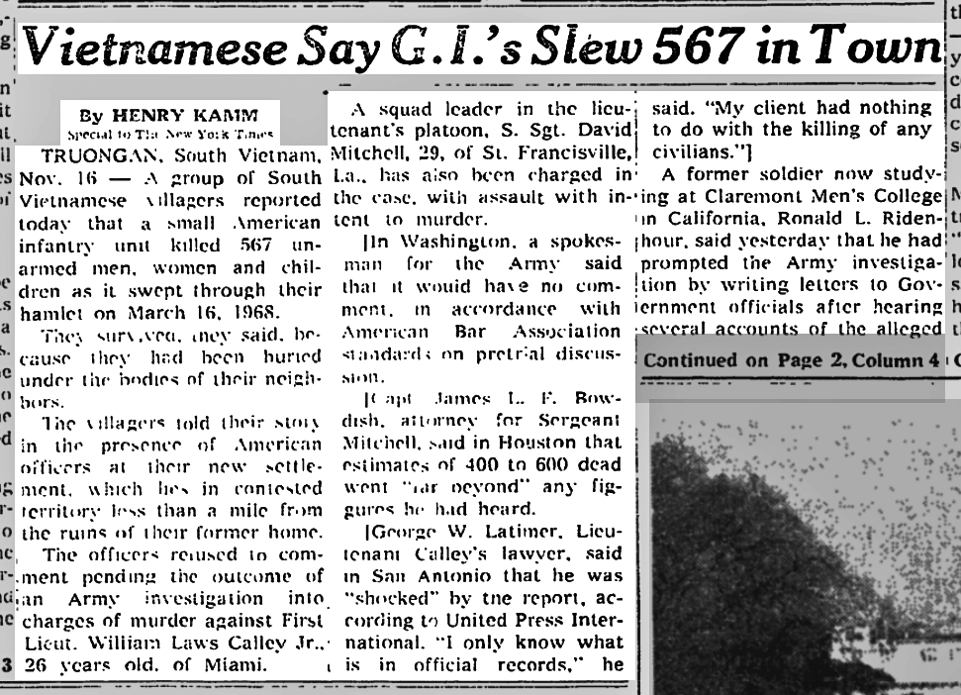

KENT STATE MASSACRE:

May 4th 1970

4 Kent State Students Killed by Troops
8 Hurt as Shooting Follows Reported Sniping at Rally

By John Kifner

Special to The New York Times

Kent, Ohio, May 4 -- Four students at Kent State University, two of them women, were shot to death this afternoon by a volley of National Guard gunfire. At least 8 other students were wounded.

The burst of gunfire came about 20 minutes after the guardsmen broke up a noon rally on the Commons, a grassy campus gathering spot, by lobbing tear gas at a crowd of about 1,000 young people.

In Washington, President Nixon deplored the deaths of the four students in the following statement:

"This should remind us all once again that when dissent turns to violence it invites tragedy. It is my hope that this tragic and unfortunate incident will strengthen the determination of all the nation's campuses, administrators, faculty and students alike to stand firmly for the right which exists in this country of peaceful dissent and just as strong against the resort to violence as a means of such expression."

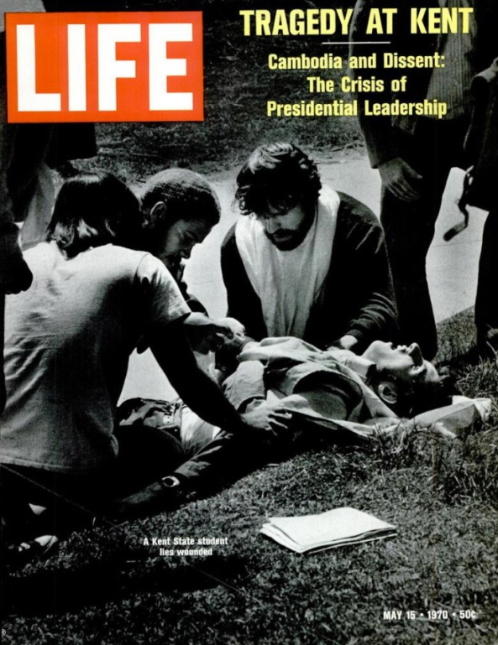
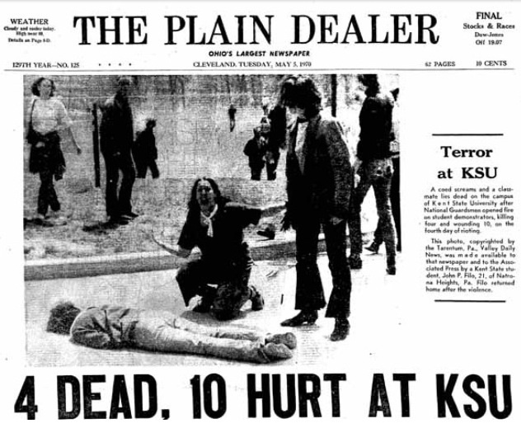
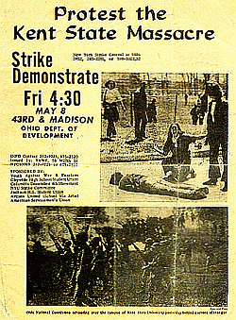
WALTER CRONKITE:
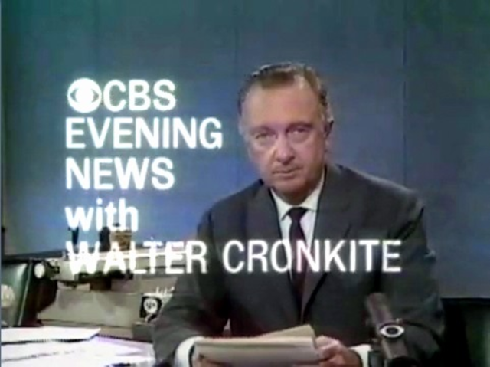
Walter Leland Cronkite, Jr. was an American broadcast journalist, best known as anchorman for the CBS Evening News for 19 years (1962–1981). During the heyday of CBS News in the 1960s and 1970s, he was often cited as "the most trusted man in America" after being so named in an opinion poll.
In mid-February 1968, on the urging of his executive producer Ernest Leiser, Cronkite and Leiser journeyed to Vietnam to cover the aftermath of the Tet Offensive. They were invited to dine with General Creighton Abrams, the then commander of all forces in Vietnam, whom Cronkite knew from World War II. According to Leiser, Abrams told Cronkite, "we cannot win this Goddamned war, and we ought to find a dignified way out."

Parting words from Walter Cronkite: His famous Vietnam commentary, originally aired on a special CBS News broadcast Feb. 27, 1968
“I wrote a three-minute closing for the program, which seemingly, without reluctance, our stern and uncompromisingly fair news president Dick Salant approved.
Tonight, back in more familiar surroundings in New York, we'd like to sum up our findings in Vietnam, an analysis that must be speculative, personal, and subjective. Who won and who lost in the great Tet Offensive against the cities? I'm not sure. The Vietcong did not win by a knockout but neither did we.
Then, with as much restraint as I could, I turned to our own leaders whose idea of negotiation seemed frozen in memories of General McArthur's encounter with the Japanese aboard the Battleship Missouri.
We've been too often disappointed by the optimism of the American leaders...
(Reading) Both in Vietnam and Washington to have faith any longer in the silver linings they find in the darkest clouds. For it seems now more certain than ever, that the bloody experience of Vietnam is to end in a stalemate. To say that we are closer to victory today is to believe in the face of the evidence, the optimists who have been wrong in the past.
To say that we are mired in stalemate seems the only realistic, if unsatisfactory conclusion. On the off chance that military and political analysts are right, in the next few months we must test the enemy's intentions, in case this is indeed his last big gasp before negotiations.
But it is increasingly clear to this reporter that the only rational way out then will be to negotiate, not as victors, but as an honorable people who lived up to their pledge to defend democracy, and did the best they could.
This is Walter Cronkite. Good night. “
Following Cronkite's editorial report, President Lyndon Johnson is claimed by some to have said, "If I've lost Cronkite, I've lost Middle America."

