Document 1: Magazine Article Excerpt:
“Therefore, it is somewhat of a rude awakening for many of these parents to find that America is facing a most serious situation regarding its popular music. Welfare workers tell us that never in the history of our land have been such immoral conditions among our young people, and in the surveys made by many organizations regarding these condition, the blame is laid on jazz music and its evil influence on the young people of today. Never before have such outrageous dances been permitted in private as well as public ballrooms, and never has there been used for the accompaniment of the dance such a strange combination of tone and rhythm as that produced by the dance orchestras of today.”
Source: Excerpt from “Does Jazz Put the Sin in Syncopation?” by Anne Shaw Faulkner, head of the Music Department, General Federation of Women’s Clubs. Published in Ladies Home Journal, August 1921.

Document 2: Quote 1 from an interview
“To me the Jazz Age signifies an age of freedom in thought and action. The average young person of today is not bound by the strict conventions which governed the actions of previous generations.”
Source: Unidentified female coed from Denver, Sunset Magazine, 1926.

Document 3: Quote 2 from an interview:
“When my grandmother found out I was playing jazz music in one of the sporting houses in the District, she told me that I had disgraced the family and forbade me to live in the house… She told me that devil music would surely bring about my downfall but I just couldn’t put it behind me.”
Source: Jelly Roll Morton, jazz composer. Culture Shock: The TV Series and Beyond: “The Devil’s Music: 1920s Jazz. PBS

Document 4: Article Excerpt
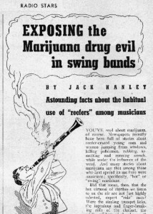
“One leader told me of a young man in his band who was a crackerjack musician, but who used the weed so consistently that he was quite undependable. The fits of deep depression reefers so often, [sic] produce would seize him until he had to be restrained, from suicide.”
Source: Excerpts from , “Exposing the Marijuana Drug Evil in Swing Bands” by Jack Haley. Published in Radio Stars, 1938.

Document 5: Photograph
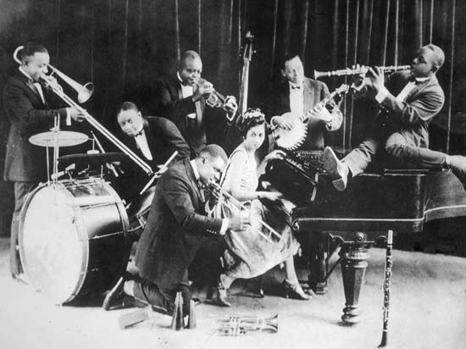
Source: King Oliver’s Creole Jazz Band 1923 by an unidentified photographer. Found in Louisiana State Museum. Found at http://media-2.web,britannica.com/eb-media/19/1919-004-2272c229.jpg.

