American Neutrality:

German Blitzkrieg: “____________________ _______”

Mechanized Warfare (examples):

1940: Countries taken by Germany:

Fall of France:

Germany occupied __________________and set up a puppet government in _______________

Charles De Gaulle:

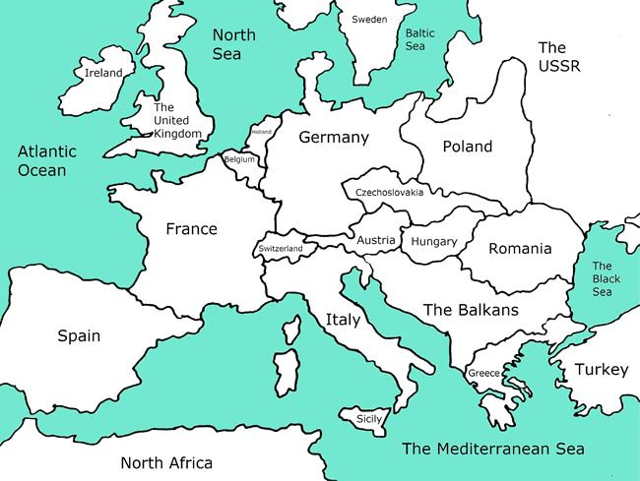

Battle of Britain:

German _______________ vs. British ________________

WW11 in Europe (1939-1941):

Germany’ s next Goal: ___________________________

American Neutrality:

Isolationism: ___________________________________

Neutrality: ______________________________________

From Isolation to Involvement:

- 1935: Neutrality Act:

- 1939: Cash and Carry:

- 1940: Selective Service (Draft):

- 1940: Lend-Lease:

