Name:
The New Deal: Success or Failure?
Directions: Examine the documents below and answer the questions that accompany each. Then, fill in the thesis template below, as if you were preparing to write an essay answering this question: “Was President Roosevelt’s New Deal a success or failure?”
What does this document say about the impact of the New Deal ?
Document A:

“The New Deal was responsible for some powerful and important accomplishments. It put people back to work. It saved capitalism. It restored faith in the American economic system, while at the same time it revived a sense of hope in the American people. But economically, it was less successful.” –

Source: From THE NEW DEAL: ACCOMPLISHMENTS AND FAILURES By Allan M. Winkler Miami University (March 31st, 2009). Allan Winkler was a distinguished history professor for over 25 years.
This document describes a success/failure of the New Deal because…

This source is or is not reliable because……

Document B:

IN DECEMBER 1932, A DISCONSOLATE YOUNG MAN, TWO OR three years out of college, sat on a park bench and watched his big toe come through his best shoe, while he tried to screw up courage to apply for relief. Two years later he was the executive head of an insurance enterprise handling millions of dollars annually, working in close conjunction with important medical and educational institutions. He, himself, has won an international reputation in his special field. His name would be known to many Survey Graphic readers.

Source: -From Survey Graphic by Douglas H. MacNeil (July 1939).
This document describes a success/failure of the New Deal because ….

This source is or is not reliable because……

Document C:

“New Deal taxes were major job destroyers during the 1930s, prolonging unemployment that averaged 17%. Higher business taxes meant that employers had less money for growth and jobs. Social Security excise taxes on payrolls made it more expensive for employers to hire people, which discouraged hiring….For example, the National Industrial Recovery Act (1933) cut back production and forced wages above market levels, making it more expensive for employers to hire people - blacks alone were estimated to have lost some 500,000 jobs because of the National Industrial Recovery Act.”

Document C continued:
Source: Jim Powell, “How FDR’s New Deal Harmed Millions of Poor People” (2003). Jim Powell is a senior member of a Libertarian think tank. (Libertarians are against taxes and government regulation)

This document describes a success/failure of the New Deal because….

This source is or is not reliable because……

Document D:
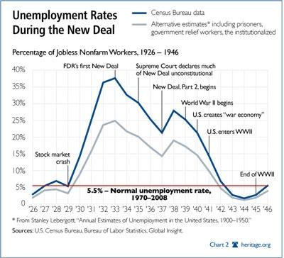
This document describes a success/failure of the New Deal because….

This source is or is not reliable because……

Thesis Statement: Use the documents above, as well as information learned throughout this unit, to create an academically appropriate and detailed thesis statement.
Ultimately, the New Deal was a success/ failure because…….

