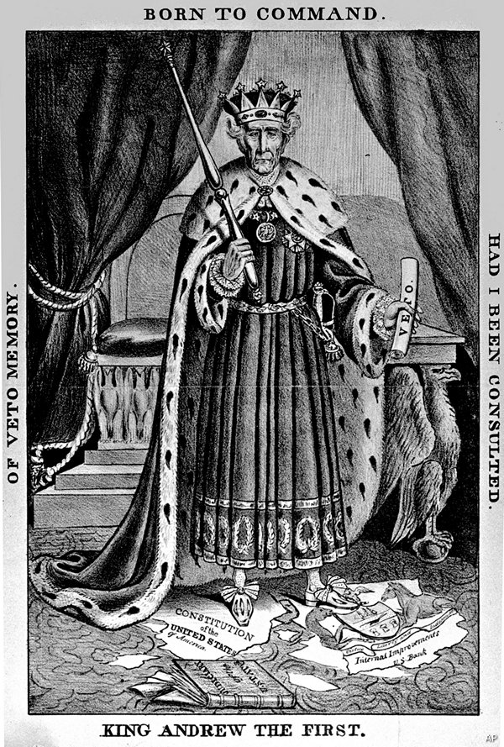
Interpreting Political Cartoons: B.A.S.I.C.
Figure 1; The print is related to Andrew Jackson's controversial veto of Congress's bill to re charter the Bank in July 1832
- Background Knowledge: When was this cartoon created? Who were the major political figures and celebrities of the era? What were the notable events, occurrences, conflicts, and controversies of the time?

- Argument: What does the artist want me to think? Complete this statement, “From this cartoon, it is the clear that the author thinks……….

- Symbolism: Symbols are part of the toolbox of every editorial cartoonist. Look for symbols is the cartoon. What do they mean? Why were they included?

- Indicators are written labels in a cartoon that point in a certain direction. Often, indicators tell us directly what something stands for. The title and caption our indicators. Other indicators are text and labels found in the body of the cartoon. Look for and list the indicators in this cartoon. Some cartoons may not have indicators:

- Caricature: Cartoons follow the adage, “What’s worth stating is worth overstating.” Look for obvious exaggerations and distortions, Caricature can also employ stereotypes, distorted images that exaggerate the features of an entire group. List the caricature’s in this cartoon.

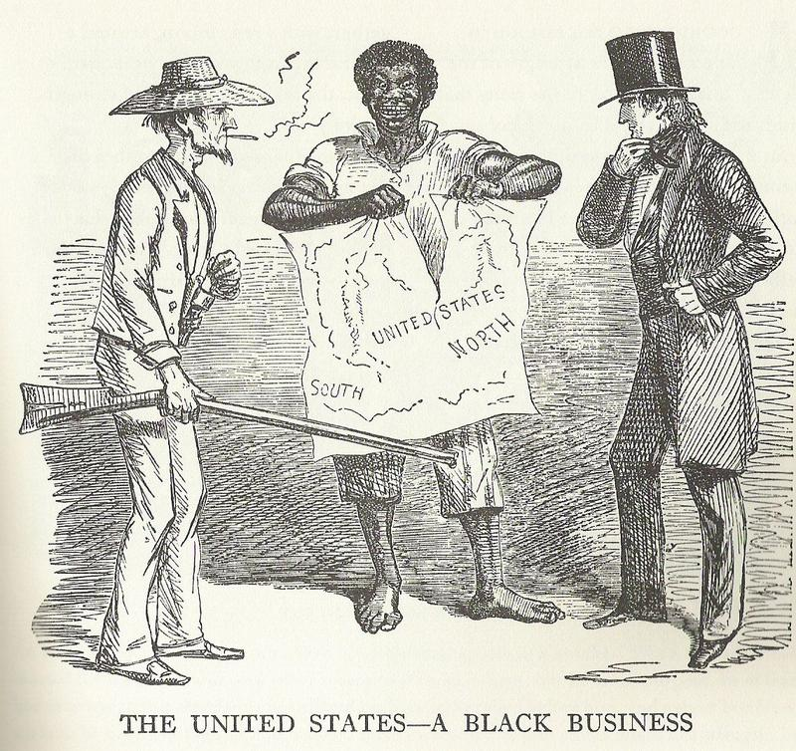
Figure 2; SLAVERY CARTOON, 1856. 'The Dis-United States - a black business.' . Published in 'Punch.'

- Background Knowledge: When was this cartoon created? Who were the major political figures and celebrities of the era? What were the notable events, occurrences, conflicts, and controversies of the time?

- Argument: What does the artist want me to think? Complete this statement, “From this cartoon, it is the clear that the author thinks……….

- Symbolism: Symbols are part of the toolbox of every editorial cartoonist. Look for symbols is the cartoon. What do they mean? Why were they included?

- Indicators are written labels in a cartoon that point in a certain direction. Often, indicators tell us directly what something stands for. The title and caption our indicators. Other indicators are text and labels found in the body of the cartoon. Look for and list the indicators in this cartoon. Some cartoons may not have indicators:

- Caricature: Cartoons follow the adage, “What’s worth stating is worth overstating.” Look for obvious exaggerations and distortions, Caricature can also employ stereotypes, distorted images that exaggerate the features of an entire group. List the caricature’s in this cartoon.

