Document #4:
Kentucky State Law (1934):
(1) Each board of education shall maintain separate schools for the white and colored children residing in its district.
(2) No person shall operate or maintain any college, school or institution where persons of both the white and colored races are received as pupils.
(3) No instructor shall teach in any college, school, or institution where persons of both the white and colored races are received as pupils.
(4) No white person shall attend any college, school or institution where colored persons are received as pupils or receive instruction.
(5) No colored person shall attend any college, school or institution where white persons are received as pupils or receive instruction. ... [1934]

Document #5:
Dr. Seuss Cartoon (1942)
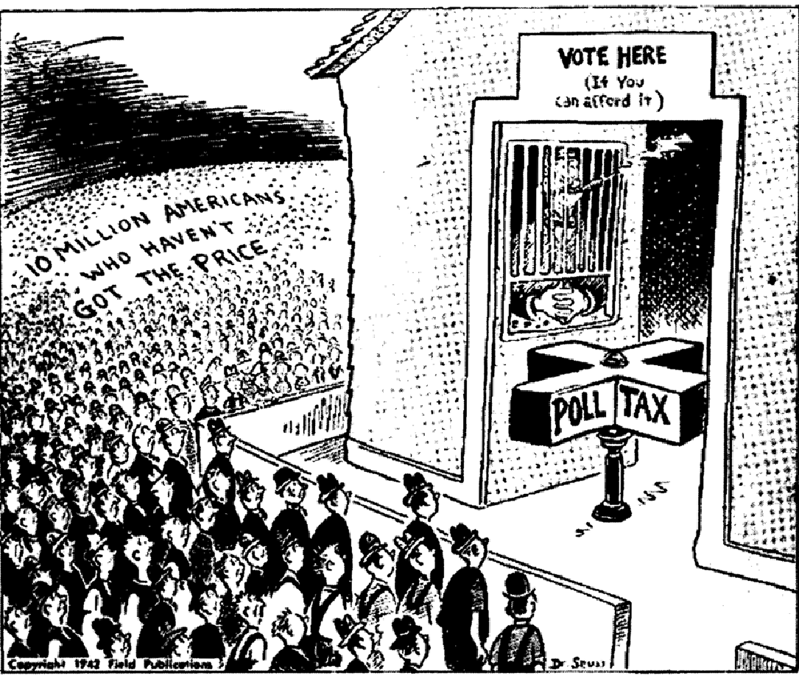

Document #6
Columbia, South Carolina Newspaper Article
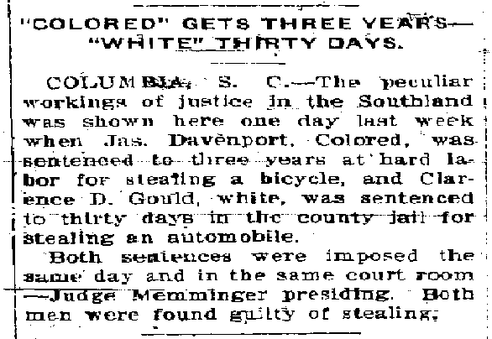
"'Colored' Gets Three Years — 'White' Gets Thirty Days."
Columbia, S.C. — The peculiar workings of justice in Southland when Jas. Davenport, Colored, was sentenced to three years at hard labor for stealing a bicycle, and Clarence D. Gould, white, was sentenced to thirty days in the county hail for stealing an automobile.
Both sentences were imposed the same day and in the same court room — Judge Memminger presiding. Both men were found guilty of stealing.
Document #7
Mississippi State Law
“ Any person guilty of printing, publishing or circulating matter urging or presenting arguments in favor of social equality or of intermarriage between whites and negroes, shall be guilty of a misdemeanor. “

Document #8: Lynching Records:

Lynching: By State and Race, 1882-1968 *
State | White | Black | Total
Alabama | 48 | 299 | 347
Arizona | 31 | 0 | 31
Arkansas | 58 | 226 | 284
California | 41 | 2 | 43
Colorado | 65 | 3 | 68
Delaware | 0 | 1 | 1
Florida | 25 | 257 | 282
Georgia | 39 | 492 | 531
Idaho | 20 | 0 | 20
Illinois | 15 | 19 | 34
Indiana | 33 | 14 | 47
Iowa | 17 | 2 | 19
Kansas | 35 | 19 | 54
Kentucky | 63 | 142 | 205
Louisiana | 56 | 335 | 391
Maine | 1 | 0 | 1
Maryland | 2 | 27 | 29
Michigan | 7 | 1 | 8
Minnesota | 5 | 4 | 9
Mississippi | 42 | 539 | 581
Missouri | 53 | 69 | 122
Montana | 82 | 2 | 84
Nebraska | 52 | 5 | 57
Nevada | 6 | 0 | 6
New Jersey | 1 | 1 | 2
New Mexico | 33 | 3 | 36
New York | 1 | 1 | 2
North Carolina | 15 | 86 | 101
North Dakota | 13 | 3 | 16
Ohio | 10 | 16 | 26
Oklahoma | 82 | 40 | 122
Oregon | 20 | 1 | 21
Pennsylvania | 2 | 6 | 8
South Carolina | 4 | 156 | 160
South Dakota | 27 | 0 | 27
Tennessee | 47 | 204 | 251
Texas | 141 | 352 | 493
Utah | 6 | 2 | 8
Vermont | 1 | 0 | 1
Virginia | 17 | 83 | 100
Washington | 25 | 1 | 26
West Virginia | 20 | 28 | 48
Wisconsin | 6 | 0 | 6
Wyoming | 30 | 5 | 35
Total | 1,297 | 3,446 | 4,743
*Statistics from theTuskegee Institute.

Document #9
South Carolina School Comparison
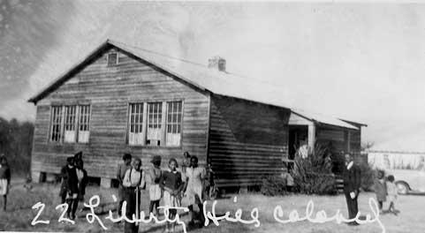

Colored” School
Because the school board refused to fund buses for black students, the county’s 61 “colored” schools were scattered throughout the region. Most, like Liberty Hill Colored School, were small wooden structures that accommodated one or two classrooms. In the 1949-50 school year, for every dollar spent on a white child only 24 cents was allotted for a black student. Not surprisingly, black adults in the county averaged just over four years of education.
(Courtesy of South Carolina Department of Archives and History)
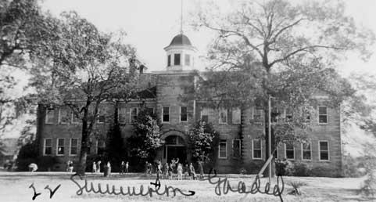

White school in Summerton
The county provided 30 buses to bring white children to larger and better-equipped facilities. White children from the Summerton area attended this red brick building with a separate lunchroom and science laboratories. Most rural black schools had neither electricity nor running water.
(Courtesy of South Carolina Department of Archives and History)

Document #10
Maryland State Law (1924)
All marriages between a white person and a negro, or between a white person and a person of negro descent, to the third generation, inclusive, or between a white person and a member of the Malay race; or between the negro and a member of the Malay race; or between a person of Negro descent, to the third generation, inclusive, and a member of the Malay race, are forever prohibited, and shall be void; and any person violating the provisions of this Section shall be deemed guilty of an infamous crime, and punished by imprisonment in the penitentiary not less than eighteen [18] months nor more than ten [10] years: Š. [Maryland Annotated Code, 1924]
Document #11
Segregated drinking fountains
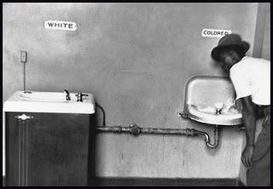

Document #12
South Carolina School Comparison
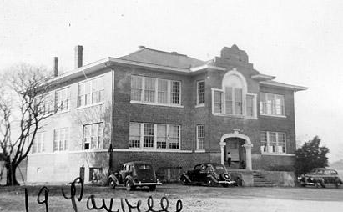
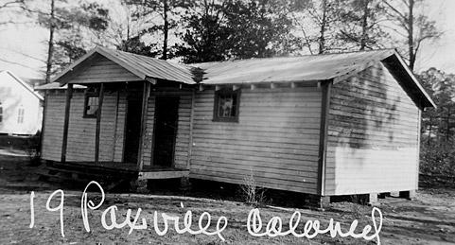
Paxville, South Carolina
“Colored” and “white” schools in Paxville, South Carolina. In some southern states, white schools received two to three times more money per student than black schools. Black taxpayers in several states not only bore the entire cost of their own schools, but helped support white schools as well.
(Courtesy of South Carolina Department of Archives and History)

Document #13
Personal narrative; “My First Trip to the South.”

"Uncle Gus?" I finally said, after driving most of the day and night. We must have been somewhere in western Texas.
"Yes Joe," he answered, looking at me in his rear-view mirror.
"When are we going to stop to sleep at the Holiday Inn?"
He laughed. But then remembering, I guess, that I was not born and raised in the South, he replied in a serious tone, "Negroes cannot stay at the Holiday Inn."
"Then let's go to another hotel," I said.
"We cannot stay there either."
"Why?"
"No white hotels rent to Negroes."
"Where will we sleep then?"
"Right where you are."
"In the back of a car seat?"
"That's it. Right in the back seat."
"What about food when we get hungry?"
"Don't worry, your Aunty Leola packed everything we need in the trunk until we arrive in Louisiana. Sometimes the stores in the South will not sell us food because we're black. Other times, we have to go to the back of the store, so that white customers won't see us."
"Why is that?"
"Many white owners think that if white customers see us they won't buy the food."
"Don't you pay with money like them?"
"Yes."
"So why do we have to go in by the back way?"
"Well, Joe, that's the way things is in the South. This is not Los Angeles, this is the South and that's just the way things are here. I don't much like them, but there is nothing we can do. Nothing!"
We drove on without stopping. Even when we finally stopped for gas, uncle Gus kept the engine running. He was afraid the white gasoline station people would not sell us gas. I remember several gas stations refused to sell us gas because they did not "sell gas to niggers."
As we were walking around the side of the building toward the rear entrance, we stopped to use the restroom. It was a large, clean, fully-equipped bathroom. The owner suddenly ran out of the store and blocked the entrance to the restroom. "Nigger, can't you read the sign? It says 'Whites Only.'"
My uncle asked politely, "Where is the restroom for coloreds?"
"It's there in the middle of the field. See right there, that's the one for niggers."
He had pointed to a cow patch in the middle of the wilderness. I walked to the spot, which was quite a distance from the road, and I kept hearing my Uncle Gus yell for me to watch out for snakes. The "colored" restroom was an old outhouse. The door was hanging off and there were holes throughout. Anyone passing could see everything. It stank and looked horrible.

Document #14
Jim Crow Education in Mississippi
“My Jim Crow education continued on my next job, which was portering in a clothing store. One morning, while polishing brass out front, the boss and his twenty-year-old son got out of their car and half dragged and half kicked a Negro woman into the store. A policeman standing at the corner looked on, twirling his nightstick. I watched out of the corner of my eye, never slackening the strokes of my chamois upon the brass. After a few minutes, I heard shrill screams coming from the rear of the store. Later the woman stumbled out, bleeding, crying, and holding her stomach. When she reached the end of the block, the policeman grabbed her and accused her of being drunk. Silently I watched him throw her into a patrol wagon.
When I went to the rear of the store, the boss and his son were washing their hands at the sink. They were chuckling. The floor was bloody, and strewn with wisps of hair and clothing. No doubt I must have appeared pretty shocked, for the boss slapped me reassuringly on the back.
"Boy, that's what we do to niggers when they don't want to pay their bills," he said, laughing. His son looked at me and grinned. "Here, have cigarette," he said. Not knowing what to do, I took it. He lit his and held the match for me. This was a gesture of kindness, indicating that even if they had beaten the poor old woman, they would not beat me if I knew enough to keep my mouth shut. "Yes, sir," I said, and asked no questions. After they had gone, I sat on the edge of a packing box and stared at the bloody floor till the cigarette went out.”

Document #15:
Marion, Indiana Lynching
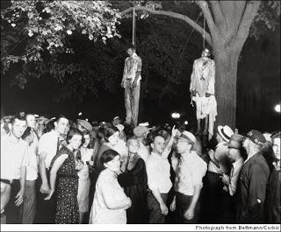
- This lynching occurred in Marion, Indiana in 1930. The two men were accused of raping a white teen, but never stood trial.

