PROHIBITION
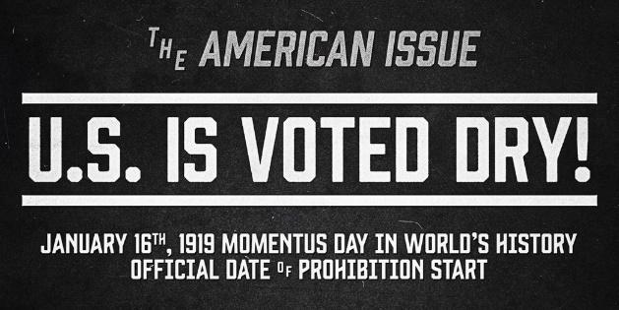
18th Amendment:…. the manufacture, sale, or transportation of intoxicating liquors within, the importation thereof into, or the exportation thereof from the United States and all the territory subject to the jurisdiction thereof for beverage purposes is hereby prohibited.
Volstead Act: The Volstead act was passed to try to enforce Prohibition

Supporters of Prohibition:
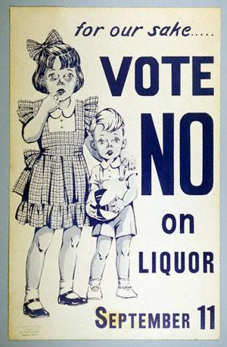
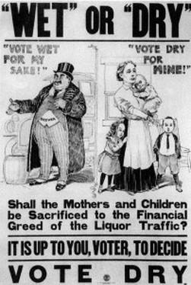
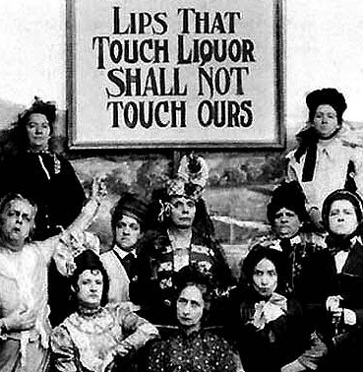

Reaction to Prohibition:
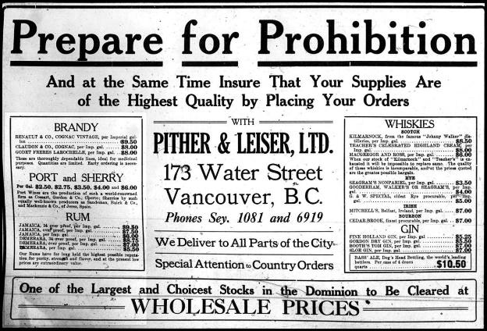
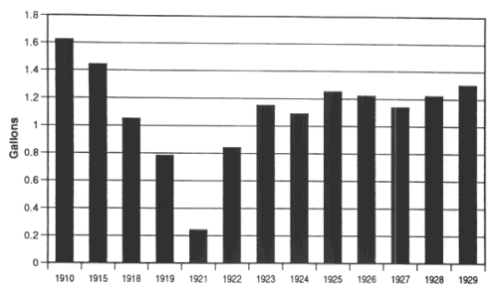

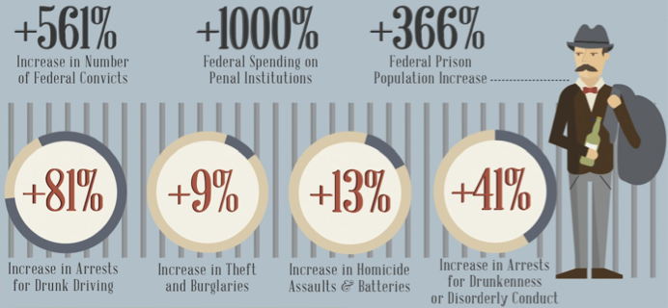

Reaction to Prohibition: “Bootleggers, Speakeasies, and the Mob”
The people who illegally made, imported, or sold alcohol during this time were called 'Bootleggers'. Bootleggers built secret breweries to make liquor and counterfeited prescriptions and liquor licenses to gain access to alcohol. Most of the alcohol was smuggled into the USA from Canada, Mexico or the West Indies. Bootlegging grew into a vast illegal empire that was rife with bribery and corruption. Prohibition Bureau agents, police, judges and politicians, received monthly bribes and retainers (up to $300,000 a month) to look the other way.
With the demand for alcohol still very high, illegal and “secret” night clubs opened up to serve the public demand. These night clubs were called speakeasies. A Speakeasy was a saloon or nightclub that sold alcoholic beverages illegally. Saloons and Speakeasy clubs claimed to sell soft drinks and coffee, but served alcohol behind the scenes. Speakeasies (speak-easies) were so named because patrons had to whisper code words to enter the illegal drinking clubs.
The Speakeasy: New York City had nearly 100,000 speakeasy clubs. Chicago had more than 7,000 speakeasies and drinking parlors. Some Speakeasies served food and had floor shows with live bands playing 1920s Jazz music and people danced the Charleston.
Prior to prohibition, mobsters and the mafia limited their activities to prostitution, gambling, and theft. With the high demand for illegal alcoholic beverages, organized crime found a new way to make money and gain power. Gangsters dominated various cities and provided bootleg alcohol for speakeasies. Each major city had its own gangster element, none bigger than the city of Chicago. An estimated 1,300 gangs operated in Chicago. The most famous mobsters in Chicago were Al "Scarface" Capone and his Chicago Mafia who fought rival gangs led by George “Bugs” Moran.
