RACE RELATION: AFRICAN AMERICANS V. KKK
The Great Migration: 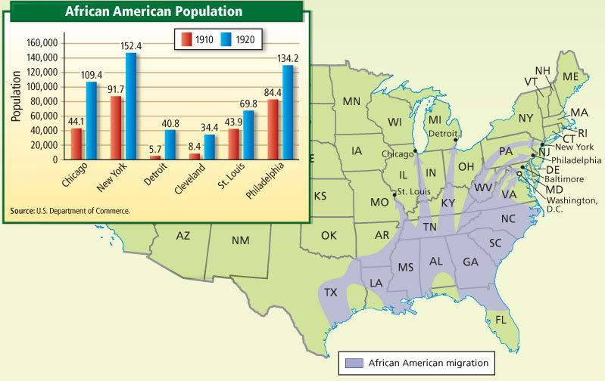
The Harlem Renaissance:
The Harlem Renaissance was a period during the 1920s when African-American achievements in art, literature and music flourished. The artistic movement centered on the neighborhood of Harlem in Manhattan, New York. The Harlem Renaissance coincided with the Jazz Age, a time of innovative ideas and modernism with rapid cultural and social changes. Harlem became a cultural center buzzing with new ideas and attracting African American scholars, writers, poets, artists, actors, musicians and singers. The Cotton Club was the most famous Harlem nightspot where musicians such as Louis Armstrong and Duke Ellington played Dixie, the blues and developed the improvisational style of music called Jazz.

Reaction to the Great Migration:
Tulsa World- June 1st 1921
St. Louis Globe-Democrat- July 1917
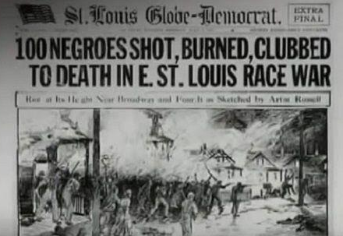
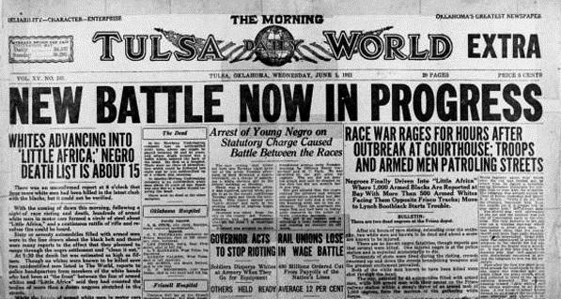
Chicago Defender August 2nd , 1919

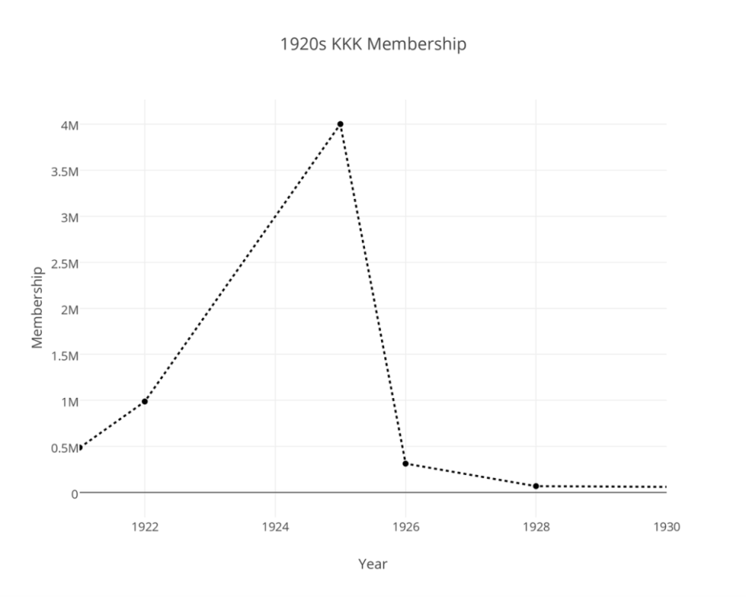
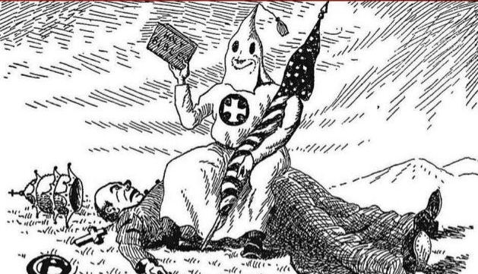
Re-emergence of the Klu Klux Klan:

