RELIGION VS. SCIENCE: FUNDAMENTALISM VS. DARWINISM
Darwin and the Theory of Evolution:
A simplified version of Darwin’s Theory of Evolution is that humans descended (or evolved) from apes. When Darwin first published his theory in 1859, it sent shock waves through the Western world. Many believed the theory was a direct threat to the legitimacy of the bible. In the years that followed his 1859 declaration, America's churches hotly debated whether to accept the findings of modern science or continue to follow the teachings of ancient scripture. By the 1920s, most of the urban churches of America had been able to reconcile Darwin's theory with the Bible.
The Rise of Fundamentalism:
Fundamentalism is the belief that the bible is literally and entirely true. Fundamentalists believe the bible was written under the direction of god and hence cannot contain any contradictions, mistruths or errors. Fundamentalism grew in strength as an ultra-conservative backlash to liberal changes that occurred in the Progressive Era and during WWI. Religious fundamentalist rejected Darwin’s theory of evolution and were weary of rapid change in society related to socialism, women’s suffrage, and the New Morality. Fundamentalism was especially prevalent in rural areas of the West and the South. In these rural areas, fundamentalists were able to pass legislation banning the teaching of evolution in public schools.
The Scopes Trial: “The Monkey Trial”
The American Civil Liberties Union led the charge of evolution's supporters. It offered to fund the legal defense of any teacher willing to fight the banning of the teaching of evolution in public school. The man who accepted the challenge was John T. Scopes, a science teacher and football coach in Dayton, Tennessee. In the spring of 1925, he walked into his classroom and read part of a chapter on the evolution of humankind and Darwin's theory of natural selection. His arrest soon followed, and a trial date was set.
The Butler Law
PUBLIC ACTS OF THE STATE OF TENNESSEE 1925
AN ACT prohibiting the teaching of the Evolution Theory in all the Universities, Normals and all other public schools of Tennessee, which are supported in whole or in part by the public school funds of the State, and to provide penalties for the violations thereof.
Section 1. Be it enacted by the General Assembly of the State of Tennessee, That it shall be unlawful for any teacher in any of the Universities, Normals and all other public schools of the State which are supported in whole or in part by the public school funds of the State, to teach any theory that denies the story of the Divine Creation of man as taught in the Bible, and to teach instead that man has descended from a lower order of animals.
Section 2. Be it further enacted, That any teacher found guilty of the violation of this Act, Shall be guilty of a misdemeanor and upon conviction, shall be fined not less than One Hundred $ (100.00) Dollars nor more than Five Hundred ($ 500.00) Dollars for each offense.
Section 3. Be it further enacted, That this Act take effect from and after its passage, the public welfare requiring it.
Passed March 13, 1925

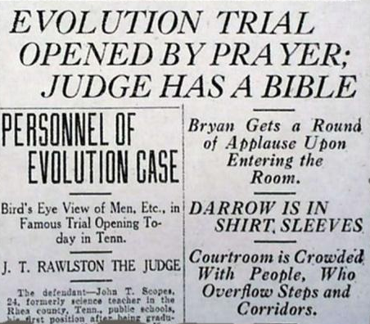
Representing Scopes was the famed trial lawyer CLARENCE DARROW. Slick and sophisticated, Darrow epitomized the urban society in which he lived.
The prosecution was led by WILLIAM JENNINGS BRYAN, three-time presidential candidate and former secretary of state. The "Great Commoner" was the perfect representative of the rural values he dedicated his life to defend. Bryan was a Christian who lobbied for a constitutional amendment banning the teaching of evolution throughout the nation.
The trial turned into a media circus. When the case was opened on July 14, journalists from across the land descended upon the mountain hamlet of Dayton. Preachers and fortune seekers filled the streets. Entrepreneurs sold everything from food to Bibles to stuffed monkeys. The trial became the first ever to be broadcast on radio.

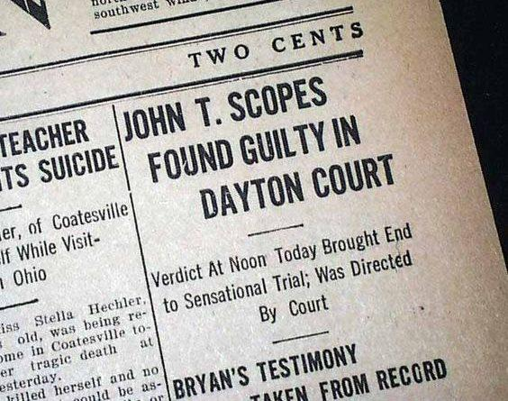

Conclusion: The jury sided with the law. Clearly, Scopes was in violation of Tennessee statute by teaching that humans descended from monkeys. He was fined $100 and released. But the battle that played out before the nation proved a victory for supporters of evolutionary theory. A later court dismissed the fine imposed on Scopes, though in the short term, the anti-evolution law was upheld.

