Spanish American War Primary Resources
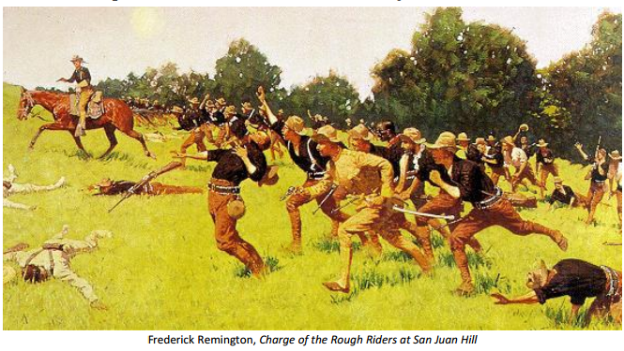
Background
The Monroe Doctrine of 1823 declared that European involvement in the Western Hemisphere would be viewed by the United States as a threat to national security. Spain had occupied Cuba since the sixteenth century, but it was not until the late nineteenth century that public opinion in the United States began to favor Cuban independence. Newspaper magnates like William Randolph Hearst and Joseph Pulitzer flooded the American public with sensationalized accounts of the Cuban struggle. This “yellow journalism” agitated for war against Spain by highlighting real and imagined Spanish atrocities. Moreover, the United States had strong interests in Cuban sugar. Citing the Monroe Doctrine and responding to overwhelming public opinion against Spain, the United States sent the USS Maine to Havana on January 25, 1898, to protect American business interests (sugar trade) and to demonstrate an interest in the conflict. On February 15, 1898, an explosion sank the USS Maine in Havana Harbor, resulting in the deaths of 274 crewmembers. Although the disaster was likely an accident, Spain was immediately blamed by the newspapers, and “Remember the Maine!” became a rallying cry in the United States. Under enormous public pressure, but unwilling to go to war, President McKinley asked Spain to give Cuba its independence. Spain refused and declared war on the United States on April 25, 1898. The United States reciprocated and within several months had destroyed the Spanish Navy and gained possession of Spain’s colonies. Virtually overnight – over the course of 113 days in 1898 – America had become a superpower.
****Answer Questions 1-4

Primary Source #1 “Who Destroyed the Maine?” New York Journal, February 17, 1898
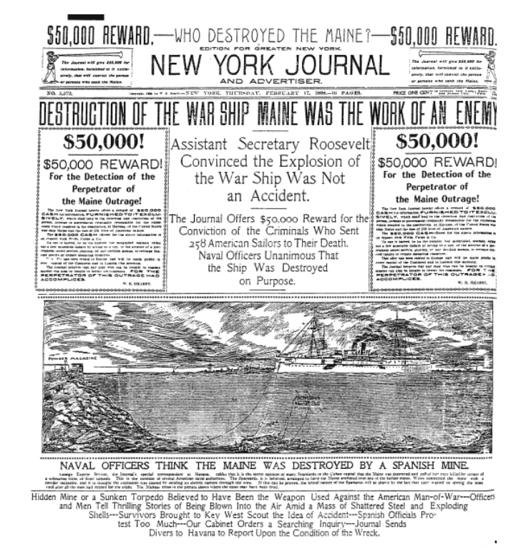

Background Information Primary Source #1:
Competing newspaper owners William Randolph Hearst and Joseph Pulitzer were master propagandists who used sensational stories about the major political and social issues of the late nineteenth century to sell newspapers. Their newspapers inflamed public opinion against Spain, helped precipitate the Spanish-American War, and increased the American public’s interest in America’s role abroad. On Feb. 15, 1898, following the explosion on the USS Maine, the ship’s commanding officer Captain Sigsbee wrote the following message:
“Maine blown up in Havana Harbor at nine-forty tonight and destroyed. Many wounded and doubtless more killed or drowned. Wounded and others on board Spanish man-of-war and Ward Line steamer. Send lighthouse tenders from Key West for crew and the few pieces of equipment above water. No one has clothing other than that upon him. Public opinion should be suspended until further report. All Spanish officers, including representatives of General Blanco, now with me to express sympathy.”
The New York Journal was owned by Hearst, and its headline: “Who Destroyed the Maine?” is a perfect example of yellow journalism. The story title read, “DESTRUCTION OF THE WARSHSIP MAINE WAS THE WORK OF THE ENEMY.” Although Captain Sigsbee cautioned against jumping to conclusions, the media had already reached a verdict.
****Answer Questions 5-8

Primary Source 2: “Information Wanted” in Judge June 11, 1898
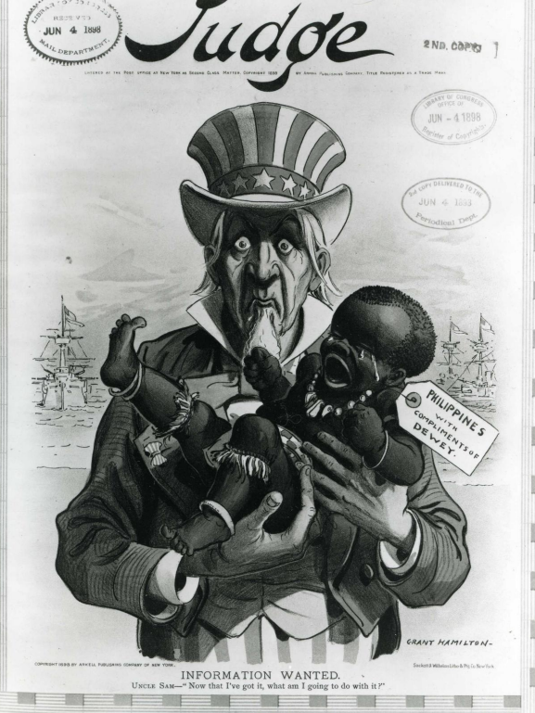

Background Information: Primary Document #2
“Information Wanted” was published in Judge in June 1898 – shortly after Commodore George Dewey’s victory over the Spanish Navy at the Battle of Manila Bay on May 1, 1898. Within a matter of hours, Dewey’s fleet had destroyed the aging Spanish Navy and had captured Manila harbor. This victory paved the way for American and Filipino forces to capture large parts of the Philippines from the Spanish Colonial Government. While this was happening, fleets from Germany, Great Britain, France, and Japan showed up in Manila Bay. They claimed they had arrived to protect the interests of their citizens, but they were also there waiting to fill the void left by the defeat of Spain. Tensions were high, and it was very clear that if the Americans left, another power would take control of the Philippines. “Information Wanted” reflects the quandary that the United States found itself in around this time. As the war drew to a close, it became more and more clear to the American public that victory against Spain was not as cut and dry as Dewey’s smashing victory made it seem. Victory had brought with it unwanted or unexpected responsibilities. The stated goal of the war against Spain had been to liberate – and now, with other powers hovering over the Philippines waiting for the chance to add it to their colonial possessions, the United States was in a difficult position.
****Answer questions 9-12

Primary Source #3: In an interview with a visiting church delegation published in 1903, President William McKinley defends his decision to support the annexation of the Philippines in the wake of the U.S. war in that country.
“When I next realized that the Philippines had dropped into our laps I confess I did not know what to do with them. . . And one night late it came to me this way. . .1) That we could not give them back to Spain- that would be cowardly and dishonorable; 2) that we could not turn them over to France and Germany-our commercial rivals in the Orient-that would be bad business and discreditable; 3) that we not leave them to themselves-they are unfit for self-government-and they would soon have anarchy and misrule over there worse than Spain's wars; and 4) that there was nothing left for us to do but to take them all, and to educate the Filipinos, and uplift and civilize and Christianize them, and by God's grace do the very best we could by them, as our fellow-men for whom Christ also died.”

Background and Aftermath: Primary Source #3
The Philippine-American War, fought from February 1899 to July 1902, claimed 250,000 lives and helped establish the United States as a power in the Pacific. On June 12, 1898, a young Filipino general, Emilio Aguinaldo, proclaimed Philippine independence and established Asia’s first republic. He had hoped that the Philippines would become a US protectorate, but pressure on President William McKinley to annex the Philippines was intense. In his words, McKinney annexed the Philippines, “to educate, to uplift, to civilize, and to Christianize,” the Filipinos. On February 4, 1899, fighting erupted between American and Filipino soldiers leaving fifty-nine Americans and approximately 3,000 Filipinos dead. American commanders hoped for a short conflict, but in the end more than 70,000 would fight in the archipelago. Unable to defeat the United States in conventional warfare, the Filipinos adopted guerrilla tactics. The war was officially declared over in July 1902, but fighting continued for several years.
The Philippine War convinced the United States not to seize further overseas territory. More than 4,000 American soldiers and about 20,000 Filipino fighters died. An estimated 200,000 Filipino civilians died during the war, mainly of disease or hunger. Reports of American atrocities led the United States to turn internal control over the Philippines to Filipinos in 1907 and to pledge to grant the archipelago independence in 1916. The 1916 Jones Act, however, delayed Philippine independence until a "stable government" was established. US leaders tried to transform the country into a showcase of American-style democracy in Asia, but there was a strong undercurrent of condescension. US President William Howard Taft, who had served as governor-general of the Philippines, called the Filipinos “our little brown brothers.” The Philippines were finally granted independence in 1946.

****Answer questions 13-17
Background: Primary Source #4
On June 15, 1898, the Anti-imperialist league formed to fight U.S. annexation of the Philippines, citing a variety of reasons ranging from the economic to the legal to the racial to the moral. It included among its members such notables as Andrew Carnegie (Leading industrialist) , Mark Twain (author), William James (politician) , and Samuel Gompers (founder of the American Federation of Labor).

Anti-Imperialist League Quotes:
"We hold that the policy known as imperialism is hostile to liberty and tends toward militarism, an evil from which it has been our glory to be free. We regret that it has become necessary in the land of Washington and Lincoln to reaffirm that all men, of whatever race or color, are entitled to life, liberty and the pursuit of happiness. We maintain that governments derive their just powers from the consent of the governed. We insist that the subjugation of any people is 'criminal aggression' and open disloyalty to the distinctive principles of our Government.”

"We hold, with Abraham Lincoln, that 'no man is good enough to govern another man without that other's consent.' When the white man governs himself, that is self-government, but when he governs himself and also governs another man, that is more than self-government – that is despotism.

"Our reliance is in the love of liberty which God has planted in us. Our defense is in the spirit which prizes liberty as the heritage of all men in all lands. Those who deny freedom to others deserve it not for themselves, and under a just God cannot long retain it." (Abraham Lincoln)
****Answer questions 18-19

