Name: ________________________________________ Date: __________________ Period: ______________

Unit 2: Progressive Era Documents
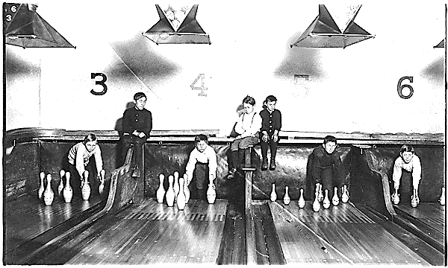
Document A: This photograph is titled, “Stacking Bowling Pins.” It was taken during the Progressive Era.

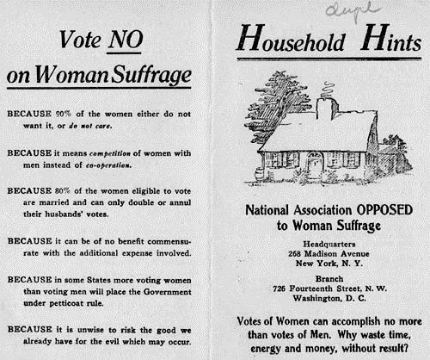
Document B: This flier was published in 1910 and handed out by women belonging to the Anti-suffrage movement.

Document C: This excerpt comes from Upton Sinclair’s book, The Jungle, Chapter 14.
There would be meat stored in great piles in rooms; and the water from leaky roofs would drip over it, and thousands of rats would race about on it. It was too dark in these storage places to see well, but a man could run his hand over these piles of meat and sweep off handfuls of the dried dung of rats. These rats were nuisances, and the packers would put poisoned bread out for them; they would die, and then rats, bread, and meat would go into the hoppers together. This is no fairy story and no joke; the meat would be shoveled into carts, and the man who did the shoveling would not trouble to lift out a rat even when he saw one…

Document D: The following quote comes from Susan B. Anthony, who was active in the early women’s rights movement.
The preamble of the Constitution says: ‘we the people of the United States…’ It was we, the people; no we, the white male citizens, but we, the whole people, who formed the Union. And we formed it, not to give the blessings of liberty, but to secure them; not to the half of ourselves and the half of our posterity, but to the whole people—women as well as men.

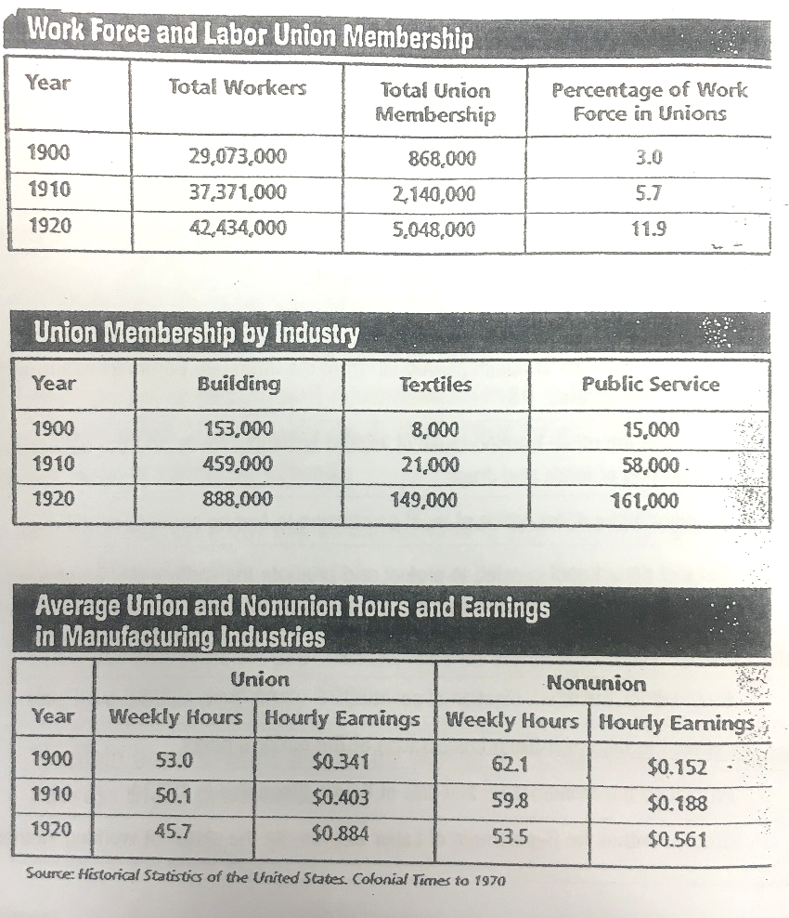
Document E: This series of graphs is titled, “Historical Statistics of the United States,” and was published in the Colonial Times magazine in 1970.

Document F: Florence Kelley was a social worker and lawyer during the Progressive Era who published essays of problems in urban centers.
Ewing Street [in Chicago]… furnishes a large contingent to the army of bootblacks [boys who shine shoes for money] and newsboys [boys who sell newspapers]; lads who leave home at 2:30 A.M. to secure the first edition of the morning paper, selling each edition as it appears, and filling the intervals with blacking boots and tossing pennies, until, in the winter half of the year, they gather in the Polk Street Night-School, to doze in the warmth, or torture the teacher with the gamin [street kid] tricks acquired by day. For them, school is "a lark," or a peaceful retreat from parental beatings and shrieking [younger siblings] at home during the bitter nights of the Chicago winter. There is no body of self-supporting children more in need of effective care than these newsboys and bootblacks. They are ill-fed, ill-housed, ill-clothed, illiterate, and wholly untrained and unfitted for any occupation. The only useful thing they learn at their work in common with the children who learn in school, is the rapid calculation of small sums in making change [money]; and this does not go far enough to be of any practical value.

 | Source:  Who wrote it?  When was it written? | Source Analysis:  What problem of the Gilded Age is the document trying to expose? | Analysis:  What argument is the author of the document making? Summarize in 1-2 sentences, using your own words
Doc. A:

Doc B:
Doc C:
Doc D:

Doc E:
Doc F:

