Name:____________________________ Period:__________________________________
Numbers don’t lie: World War II Homefront Data:
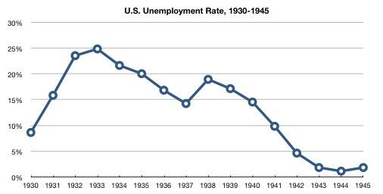
- How did the preparation for war and the supply of war materials to warring nations (1938-1941) affect the unemployment rate in the United States?

- The year prior to America entering WWII (1941) the unemployment rate was approximately _______.

- The first year American was involved in WWII (1942) the unemployment rate was approximately _______.

- Use the graph above to write a statement associating The Great Depression (1930-1940), unemployment, and World War II (1941-1945).

Population Growth in Washington, Oregon, and California, 1940-1945 (Populations in millions)
 | 1940 | 1941 | 1942 | 1943 | 1944 | 1945 | % growth  1940-1945
Washington | 1.7 | 1.8 | 1.9 | 2.1 | 2.1 | 2.3 | 35.3%
Oregon | 1.1 | 1.1 | 1.1 | 1.2 | 1.3 | 1.3 | 18.2%
California | 7.0 | 7.4 | 8.0 | 8.5 | 9.0 | 9.5 | 35.7%
Total | 9.8 | 10.3 | 11.0 | 11.8 | 12.4 | 13.1 | 33.7%
- Out of the three states observed, which state experienced the largest population growth?____
- During which year did the Pacific Coast states experience the largest population growth?_____
- Why did the Pacific Coast experience such a significant population growth during the WWII era?

Federal Spending and Military Spending during World War II (dollar values in billions of constant 1940 dollars)
 | Federal Spending |  |  | Defense Spending
Year | total $ | % increase | % of GDP | total $ | % increase | % of GDP | % of federal spending
1940 | 9.47 |  | 9.34% | 1.66 |  | 1.64% | 17.53%
1941 | 13.00 | 37.28% | 10.77% | 6.13 | 269.28% | 5.08% | 47.15%
1942 | 30.18 | 132.15% | 21.70% | 22.05 | 259.71% | 15.86% | 73.06%
1943 | 63.57 | 110.64% | 46.59% | 43.98 | 99.46% | 32.23% | 69.18%
1944 | 72.62 | 14.24% | 41.54% | 62.95 | 43.13% | 36.00% | 86.68%
1945 | 72.11 | -0.70% | 41.56% | 64.53 | 2.51% | 37.19% | 89.49

- What was the trend of federal spending from 1940-1945?
- What year did defense spending experience the biggest increase in total $?
- Why did federal and defense spending increase so drastically in the World War II era?

Warplanes produced 1940 to 1945:
 | Great Britain | USA | USSR | Germany | Japan
1940 | 15,000 | 6,100 | 7,000 | 10,200 | 4,800
1941 | 20,100 | 19,400 | 12,500 | 11,000 | 5,100
1942 | 23,600 | 47,800 | 26,000 | 14,200 | 8,900
1943 | 26,200 | 85,900 | 37,000 | 25,200 | 16,700
1944 | 26,500 | 96,300 | 40,000 | 39,600 | 28,200
1945 | 12,100 | 46,000 | 35,000 | not known | 11,100
Total | 123,500 | 301,500 | 157,500 | 100,200 | 74,000

- Which country produced the most warplanes during 1940?
- Which country produced the most warplanes in 1942?
- What was the difference between the total war planes produced by the United States and the combined total of warplanes produced by Japan and Germany?
- What does this chart display about American production on the homefront during WWII?

